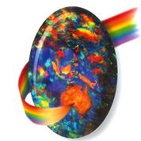Opal Association Incorporated 15th February 2017

PRESS RELEASE

**AUSTRALIAN OPAL TRAIL -A OUT BACK EXPERIENCE**

The Australia Opal Show Circuit is a series of annual shows from April to August. The weather is mild at this time, so you can enjoy an outback adventure without the harsh summer temperatures. There are five opal festivals to see and together they make up the Australian Opal Show Circuit.

So, what are you waiting for? Plan your Outback adventure now!

The Coober Pedy show, specialising in rough and cut opal, will be held on the 15th and 16th April. The trade show, located in outback South Australia coincides with the Opal Festival, offering visitors a vast array of entertainment over the Easter long weekend.

The Queensland Boulder Opal Association holds an annual show in Winton. Trading will be held on 7th and 8th July 2017. This wonderful outback opal event is open to the general public.

The four-block outback town of Yowah celebrates its uniqueness with an annual festival. Yowah opal celebrations occur on the third weekend of July each year and is located two hours’ drive from Cunnamulla on a sealed road.

The Lightning Ridge Opal Festival will run from 27th to 30th July, and includes the Opal Queen Ball and the Opal and Gem Expo. In 2017, the International Opal Jewellery Design Awards show and jewellery competition will be held, showcasing the stunning use of opal by jewellery designers around the world.

The Australian Opal Exhibition on Queensland’s Gold Coast allows mine owners, wholesalers and manufacturers of opal jewellery to present a huge selection of opals and opal jewellery in a pleasant fair ambience. The exhibition will be held at Surfers Paradise QT resort on 3rd and 4th August 2017.

There is also the Anakie Gemfest which does have some opal on display. it is an annual 4-day festival of gems providing a unique gemstone and jewellery experience and featuring some of the finest Australian Sapphires you will ever see. The exhibition will be held on 10th to 13th August 2017.

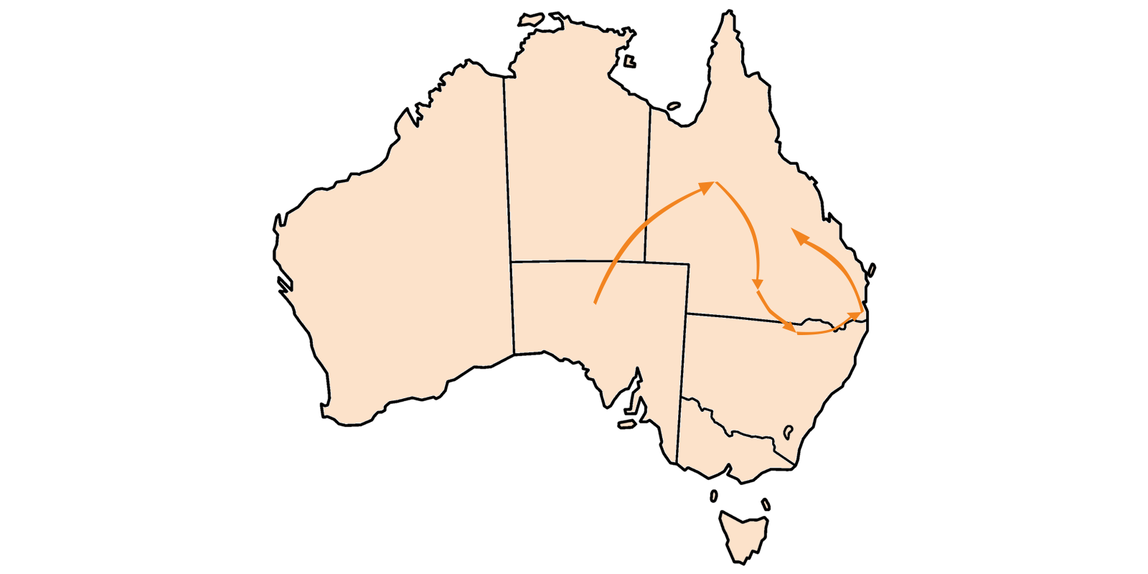

--------------------------------------------------------------------------------------------------------------

**MEDIA CONTACT**

All enquiries and photographs:

Paul Sedawie

President Opal Association Incorporated

Email: info@opal.asn.au

--