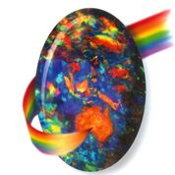Opal Association Incorporated 15th March 2017

PRESS RELEASE for Immediate Release

**AUSTRALIAN OPAL CIRCUIT A MUST-DO FOR ROCK HOUNDS**

Every year some of the most remote and quirky Australian outback towns come alive for a few days of fun and fortune, when the local miners and townsfolk put on a gem fair bash like no other! Whilst for most of the year the hard work goes on well behind the scenes on sun-scorched mining claims, this collection of opal festivals brings an opportunity for each town to showcase the very best that opal has to offer.

The Australia Opal Show Circuit is a series of shows (mostly open to the public) that are run from April until August every year. The weather is beautifully mild at this time of the year, so you can enjoy a real outback adventure without the harsh summer temperatures. It’s a great way for people from all walks of life to travel around the country and see some of the most amazing opals and gemstones that Australia has to offer.

There are six fabulous opal and gemstone festivals to see each year and together they make up the Australian Opal Show Circuit.

So, what are you waiting for? Plan and book your Aussie Outback adventure now!

**Coober Pedy Gem Trade Show**

The 2017 Coober Pedy Gem Trade Show, specialising in rough and cut opal, will be held on the 15th and 16th April. The trade show, located in outback South Australia coincides with the Opal Festival, offering visitors a vast array of entertainment over the Easter long weekend.

The Croatian Club hosts the Gem Trade Show, providing a professional and air-conditioned environment for the numerous local and national exhibitors who will showcase high quality opals at trade prices to international and domestic buyers.

The Coober Pedy Gem Trade Show continues to strengthen its reputation as one of Australia’s pre-eminent opal trade shows. Organisers will be continuing the tradition of holding a welcoming dinner on the Saturday night, 15th April so that exhibitors and buyers can meet in a relaxed environment with the aim of establishing and strengthening business networks.

**Winton Opal Trade Show**

The Queensland Boulder Opal Association holds an annual Opal Trade Show in Winton at the beginning of July. The Winton Opal Trade Show is held at the North Gregory Hotel in the centre of the main street, with the Beer Garden being the area for cut and polished stones and Jewellery, and the adjoining Car Park is for tailgating.

In 2017, trading will be held there for two full days on 7th and 8th July and this wonderful outback opal event is open to the general public.

Boulder Opal Jewellery Design Awards and Opal Inspired Dress Design Awards are held each year with the judging carried out at the time of the Opal Trade Show.

**Yowah Opal Festival**

Yowah is an absolute gem of a place! This little four block town in Outback Queensland celebrates their uniqueness with an annual festival – The Yowah Opal Festival. Yowah opal celebrations occur on the third weekend of July each year and is located two hours’ drive from Cunnamulla on a sealed road.

World class museum specimens of Yowah Nut Opal, Ironstone Matrix Opal, Opalized Wood Opal, Yowah Boulder Opal and Boulder Opal are on display as the locals share their prize collections with all. The Yowah Opal festival is fully catered and licensed for the festival weekend. Morning and afternoon tea, and three meals a day are cooked on the premises. Fresh food is provided including pit roasts, bar-b-ques, and smorgasbord to offer variety over the three days. And music and dancing is also very much part of the festivities.

The townspeople encourage everyone to talk to a miner. Yowah is billed as the ‘friendly opal field’ and local people gather to prove to you why!

**Lightning Ridge Opal Festival**

In the 1980’s the Lightning Ridge Opal Festival became a hallmark event with locals, attracting hundreds of people to the social activities. Aspiring locals provided their version of ‘celebrity’ entertainment such as tributes to Michael Jackson, Cindy Lauper and even Dr Who! Around this time, the Opal & Gem Expo was first launched. An opal and gem trade show was set up in the car park of the Lightning Ridge Bowling Club and the event attracted hundreds of miners, jewellers, wholesalers and opal trade from all over Australia.

Today the Lightning Ridge Opal Festival is a 4-day event on the last weekend of July, and in 2017 will run from 27th to 30th July. The Opal Festival includes the Opal Queen Ball and the Opal and Gem Expo. The Lightning Ridge opal festival, in outback New South Wales attracts around 4000 people over the four days, and the event is billed as the largest on the Australian opal events circuit. And in 2017 there is an extra bonus to enjoy… the International Opal Jewellery Design Awards! This is a biennial event that runs concurrently with the Lightning Ridge opal festival to promote freeform and or undulating opal, and showcases the stunning and innovative use of opal by jewellery designers around the world.

**Australian Opal Exhibition Gold Coast**

The Australian Opal Exhibition on Queensland’s Gold Coast allows mine owners, wholesalers and manufacturers of opal jewellery to present a huge selection of opals and opal jewellery in a pleasant fair ambience.

Different types of opals, collectibles, polished stones, plus fine and fashion jewellery opals are seen at the show. The fair is aimed exclusively at professionals who can build on their new collections for their needs.

The Australian Opal Exhibition Gold Coast will be held at the landmark Surfers Paradise QT resort on 3rd and 4th August 2017.

**Anakie Gemfest**

Gemfest – Festival of Gems is an annual 4-day exhibition providing a unique gemstone and jewellery experience including offerings from respected local, national and international gemstone traders, quality entertainment and food, and some of the finest Australian Sapphires you will ever see.

Held every August at the Allan King Memorial Park in Anakie, Gemfest is a showcase for Australian and International gemstones. Each year thousands of visitors come from far and wide to share the excitement, enjoy the gem fields and marvel at the gems on display.

The festival enjoys a high industry profile as one of Australia’s premier gem shows and this year promises to be another huge success. In 2017, Anakie Gemfest will be held on 10th to 13th August and affords an ideal opportunity to enjoy the Central Queensland Sapphire Fields.

**The Australia Opal Show Circuit**

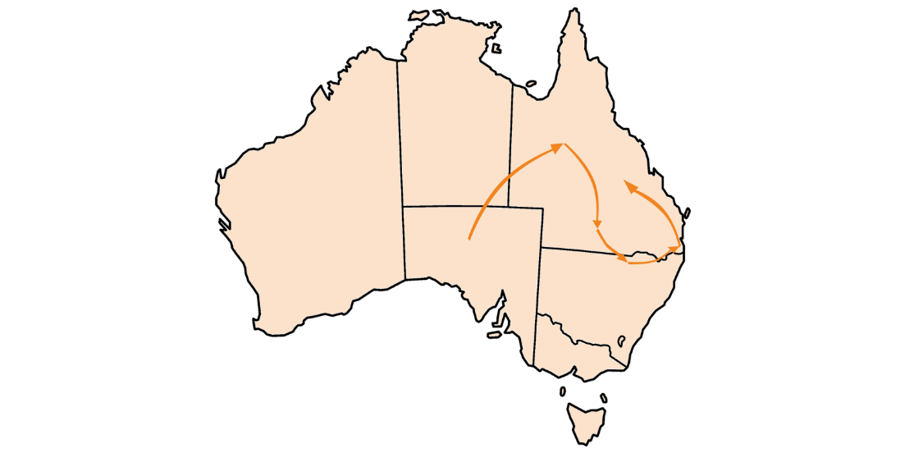

--------------------------------------------------------------------------------------------------------------

**MEDIA CONTACT**

All enquiries and requests for photographs may be directed to:

Paul Sedawie

President Opal Association Incorporated

Email: info@opal.asn.au

Opal Association Inc

PO Box 323

Mermaid Beach

QLD 4218

**ABOUT OPAL ASSOCIATION INCORPORATED**

The Opal Association was incorporated in 2000 and has subsequently attracted a diverse membership of opal miners, cutters, manufacturers, wholesalers and retailers of many years’ experience. The Association is based in Australia and has industry members from around the world.

We always welcome opal companies and enthusiasts who would like to become members. The Opal Association is administered by an executive committee that meets quarterly. All members and visitors are welcome to attend.

