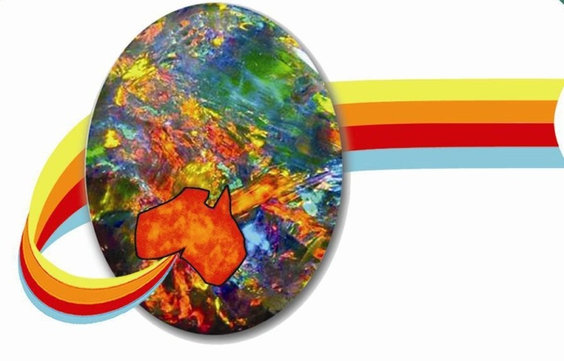**_______________________**

Opal Association

Po Box 323

Mermaid Beach QLD 4218

Australia

3 April 2017

To King opals

                    Thank you for your recent email on the 18 Jan confirming you will abide by the Opal Association rules.

On March the 22nd 2017 I made an unannounced inspection of the shop. While I did see some signs saying “Synthetic opal” I do have the following concerns;

* All members of the Opal association who sell synthetic opals are to display the sign “synthetic/man made opal” and also in the language of their main customers which in your shop would be Chinese. This also applies to invoices on sales.
* I was very concerned to see a selection of synthetic opal triplets near the back of the shop which had no description or pricing displayed anywhere in the cabinet. It is a requirement that these be labelled as “Synthetic/man made” in English and Chinese. While not a requirement of the Opal Association most members have display charts to inform the customer of how doublets and triplets are made so the customer is fully informed when purchasing.
* Doublets that have been set in jewellery should also be clearly labelled as such so the customer doesn’t get confused that they are solid opals. I did not see any evidence that they are labels as such. This also applies to invoices for such sales
* I am concerned that opal from Ethiopia and Mexico did not appear to be labelled as such

Our concern is that the labelling is insufficient to meet the standards of the Opal Association and that customers are not clearly informed about their purchase.

As mentioned I have had meetings with the minister for trade and tourism Steven Ciobo MP to express our concerns with misleading descriptions of synthetic opals in Australian retail shops and will forward a copy of this letter to him.

I will also be forwarding a copy to Qld fair trading and Austrade-aud division.

Yours sincerely

Paul Sedawie

President of the Opal Association

<http://www.opal.asn.au/opal/>