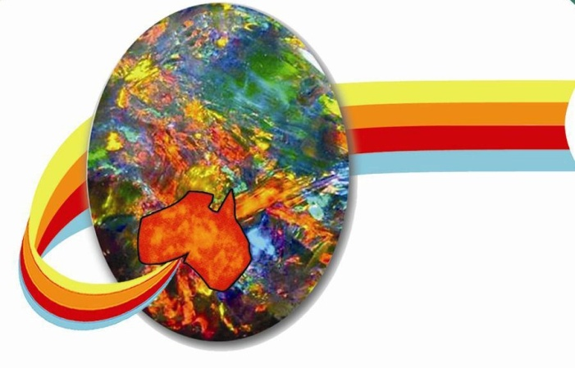_______________________
Opal Association
Po Box 323
Mermaid Beach QLD 4218
Australia

Invoice
ABN 14 577 815 732
Date 04/07/2022 Member #
Description of goods and services

Youth | $50 | Under 30
Basic | $200
Medium Business | $500 | Can have three different company names.
Export | $1000 | Must complete minimum 4 Overseas Shows pa

No GST – this entity is not GST registered

Paypal is now activated so you can just log into your membership and make payment through Paypal.

Regards Paul Sedawie President

