Study Guide For Opal Certification Test

<https://www.australianopalcentre.com/opal>

<https://geology.com/gemstones/opal/synthetic-opal.shtml>

<https://www.gia.edu/doc/Synthetic-or-Imitation-An-Investigation-of-the-Products-of-Kyocera-Corporation-That-Show-Play-Of-Color.pdf>

<https://www.gia.edu/gems-gemology/spring-2022-gemnews-sugar-heat-treated-opal>

<https://www.gia.edu/gems-gemology/spring-2014-gemnews-large-oolitic-opal>

<https://www.gia.edu/doc/GG-SP16-Lab-Notes.pdf>

<https://www.gia.edu/gems-gemology/winter-2017-gemnews-update-dyed-hydrophane-opal>

<https://www.opal.academy/home/2019/7/24/opal-nomenclature>

<https://www.opal.academy/library-index>

<https://gem-a.com/gem-hub/gem-knowledge/types-opal-gemstone>

BEGINNER'S GUIDE: WHAT ARE THE DIFFERENT TYPES OF OPAL?

**Are you fascinated by the beautiful colours of opal? Do you wish you knew more? Here, Gem-A assistant gemmology tutor, Charlie Bexfield FGA DGA EG offers a beginner's guide to opal types, including common and precious varieties.**

Types of Opal

Opal is comprised of tiny silica spheres, formed when silica-rich water seeps into deep cracks and voids in the Earth’s crust.

It is separated into two groups, common opal (also known as potch) and precious opal (also known as noble opal). Opal can be found all over the world from Cornwall to Canada, Australia to Siberia, Ethiopia, Madagascar and many other locations.

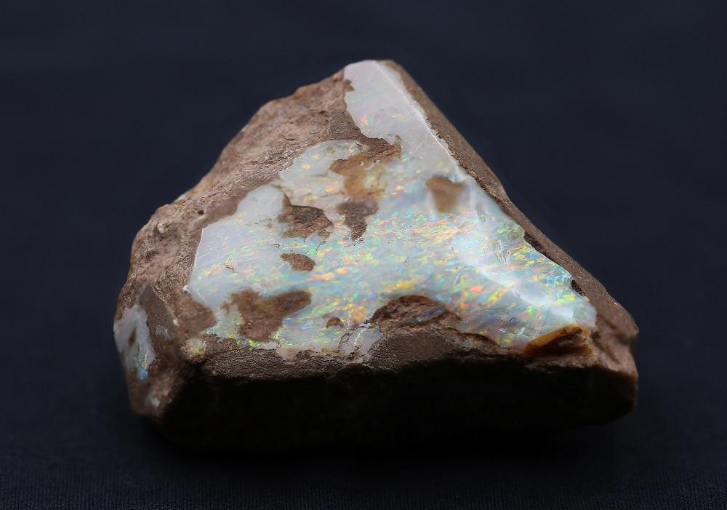*A cross section of opal in its host rock. Photograph by Henry Mesa.*

What is the difference between precious and non-precious opal?

Precious opal shows a play of spectral colours though the stone whereas common opal does not. Common opal is usually opaque to translucent and brownish orange in colour, however it can come in any colour, some of which are quite attractive.

Key Varieties of Common Opal

AGATE OPAL

The banded variety of common opal which can form in opalised fossils or in veins.

DENDRITIC OR MOSS OPAL

These moss like (dendritic) inclusions are formed of different iron minerals encased by the opal producing these aesthetic designs. Other names include 'landscape' opal in which the branch like structures of the iron minerals resemble that of a woodland landscape.

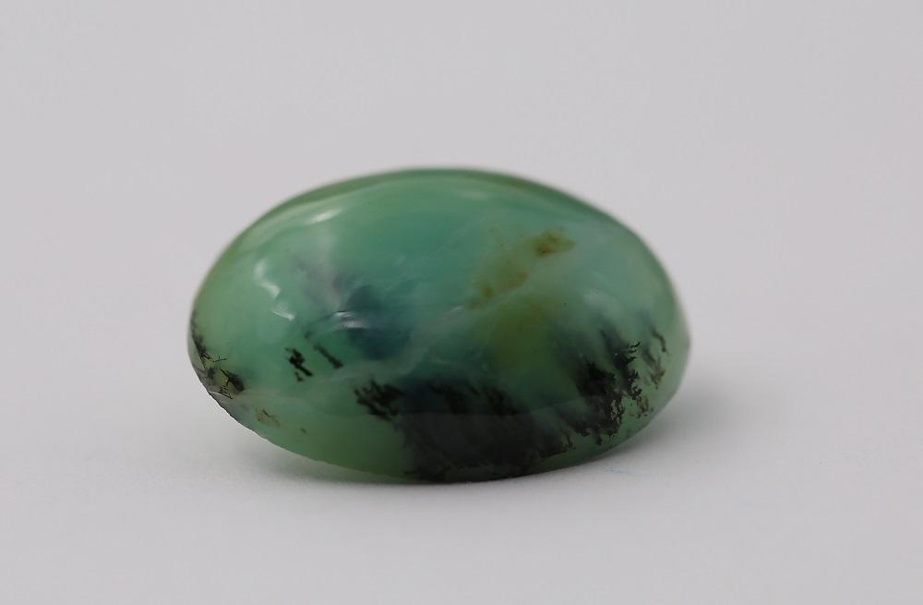*Common green opal with dendritic inclusions, also known as moss opal. Photograph by Henry Mesa.*

Some of the more sought after common opal comes from Peru. Very pretty blues, pinks and bluish greens can be found there. These come from the two main provinces: Ica and Caraveli. The best blues come from Caraveli and are known as Andean opal. Ica produces the better pinks, but both mines produce both colours.

**Read more:**[**Questions to Ask When Buying Gemstone Jewellery**](https://gem-a.com/news-publications/news-blogs/gems-from-gem-a/gem/buying-guide-gemstone-jewellery)

There are many more varieties of common opal but two other important varieties are fire opal - this is the intense orange colour opal - and hyalite, the translucent variety of opal that doesn’t display a play of colour.

Understanding Precious Opal

This variety of opal displays play-of-colour. Diffraction of light through very small apertures between silica spheres within the structure creates these flashes of colour. This cannot be confused with the reflections caused by foils within simulant opals, as play-of-colour is prismatic or rainbow-like.

**Read more:**[**How to Assess the Value of an Opal**](https://gem-a.com/news-publications/news-blogs/from-the-archives/from/retail-focus-opals)

Basil Anderson sums up the identification of precious opal quite wonderfully with this quote, included in *The Opal Book* by Frank Leechman: "As regards to identification, there is little that need be said concerning opal, since, except in the variety of fire opal, it is a stone that cannot effectively be imitated, as soon as prismatic colours are seen."

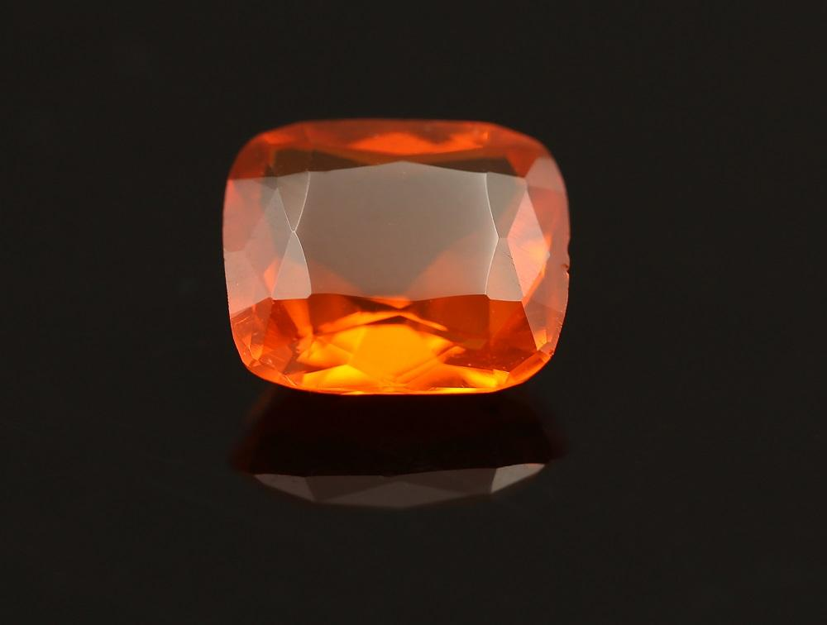*A cushion-cut fire opal. Photograph by Henry Mesa.*

This quote still stands today. Red, orange and yellow are the most desired spectral colour to be seen in opal and therefore command higher prices. Blue and green are less desirable colours, although still beautiful.

WHITE OPAL

This is the most ubiquitous variety of opal. It has a white background and is sub-transparent to translucent and usually displays opalescence. The best examples will show all the spectral colours. It is now considered to be less valuable than black opal.

However fine white opal still commands high prices and is very attractive. Most white opal comes from Marla, Australia and Whitecliffs, Australia, but is also found in Hungary, Ethiopia and Canada.

BLACK OPAL

Displaying a black body colour with little to no opalescence, this variety is now the most desirable. The black background allows the yellows, oranges and reds to ‘pop’ in contrast to the dark background, supposedly making the play of colour more impressive.

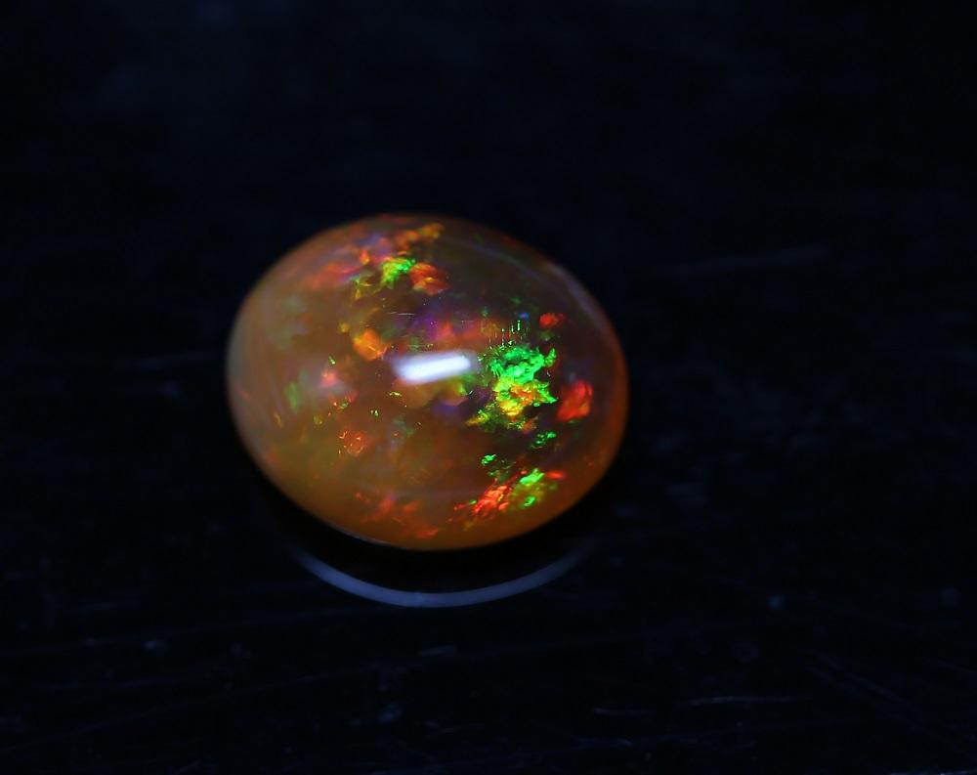*An opal cabochon with flashes of orage, red and green. Photograph by Henry Mesa.*

Once again the intensity and fullness of the play-of-colour contributes to the pricing. Black opal predominantly comes from Lightning Ridge, Australia, but can also be found Hungary, Honduras and the USA.

BOULDER AND MATRIX OPAL

These varieties occur when opal forms in narrower veins and is cut and polished within the host rock. Boulder opal was first discovered in Queensland, Australia, it can also be found in Brazil and Canada.

**Read more:**[**Top 10 Luxury Jewellery Brands**](https://gem-a.com/news-publications/news-blogs/from-the-archives/from/best-luxury-jewellery-brands)

Boulder opal veins are larger than matrix opal veins which form as a fine network within the host rock. Matrix opal is found near Yowah in Queensland, Australia.

WATER OPAL

This is the colourless variety of precious opal and can have a soft appearance. Usually the play-of-colour appears to be inside the stone against a colourless transparent background, which means it can appear minimal. The best examples are from Mexico, other localities include Australia and the USA.

What about Composites?

DOUBLET

Comprised of two parts glued together, the top is a slice of opal on a dark opaque backing made of plastic or another gem material. In the more convincing examples ironstone is used in an attempt to mimic the host rock of boulder opal.

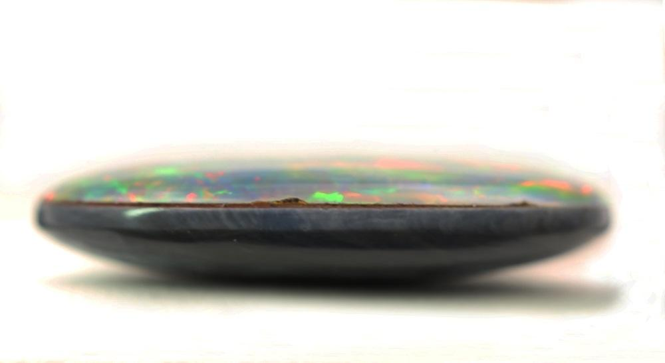*An opal doublet, pictured to highlight the seam between the slice of opal and its dark opaque backing.  
Photograph by Henry Mesa.*

TRIPLET

Very similar to the doublet, but the slice of opal is much thinner and crowned by a transparent colourless domed cabochon made of quartz, plastic or glass. This does two things, it protects the opal and also works as a magnifier for the play of colour. Viewed from the side, the colourless material can easily be spotted. Once again it is mounted on a dark opaque background to give the appearance of black opal.

<https://geology.com/gemstones/opal/>

## What Is Opal?

Opal is one of the world's most popular [**gemstones**](https://geology.com/gemstones/) and the [**birthstone**](https://geology.com/gemstones/birthstones/) for the month of October. A nice precious opal can flash every color of the spectrum with an intensity and quality of color that surpasses the fire of [**diamond**](https://geology.com/diamond/). The best opals command prices per carat that rival expensive diamonds, [**rubies**](https://geology.com/gemstones/ruby-and-sapphire/), [**sapphires**](https://geology.com/gemstones/ruby-and-sapphire/), and [**emeralds**](https://geology.com/gemstones/emerald/).

There are many types of opal found in deposits around the world. If you are just starting to learn about opal, here are three varieties that might surprise you: [**Fire Opal**](https://geology.com/gemstones/opal/fire-opal.shtml) is known for its intense red, orange and yellow colors - the colors of a fire! [**Boulder Opal**](https://geology.com/gemstones/opal/boulder-opal.shtml) is opal with attached host rock. It can be surprisingly beautiful! [**Common Opal**](https://geology.com/gemstones/opal/common-opal.shtml) has color, pattern and beauty that can be anything but common. Who gave it such a common name?

Mineralogically, opal is a hydrous silicon dioxide with a chemical composition of SiO2**.**nH2O. It is amorphous, without a crystalline structure, and without a definite chemical composition (it contains a variable amount of water, as shown by the "n" in its chemical composition). Therefore opal is a "[**mineraloid**](https://geology.com/minerals/mineraloids/)" rather than a "[**mineral**](https://geology.com/minerals/)."

## Opal Can Be Fragile!

Opal is a wonderful stone for earrings, pendants, and brooches. These items of jewelry normally do not receive significant abrasion and impact during wear. Opal is softer and more easily chipped than most other popular gemstones. It has a hardness of about 5.5 to 6.0 on the [**Mohs hardness scale**](https://geology.com/minerals/mohs-hardness-scale.shtml).

When used in a ring, the best designs have a bezel that fully protects the stone - instead of being placed in a prong setting that exposes the stone to impact and abrasion. Opal rings are beautiful and many people enjoy them. If you decide to wear an opal ring, it is best removed during activities when impact or abrasion might occur.

|  |  |
| --- | --- |
| Physical Properties of Opal | |
| **Chemical Classification** | A hydrated variety of amorphous silica |
| **Color** | Commonly having a bodycolor of white, yellow, gray, black, or brown; however, the bodycolor of opal can be any color. Some of the most beautiful common opals are red, orange, pink, green,or blue. The play-of-color of precious opal displays spectral colors of red, orange, yellow, green, blue, and violet. |
| **Streak** | White |
| **Luster** | Rough opal can have a dull, pearly, waxy, or vitreous luster. Most opal polishes to a vitreous luster. |
| **Diaphaneity** | Translucent, opaque, semi-transparent, and, rarely, transparent. |
| **Cleavage** | None, breaks with a conchoidal fracture. |
| **Mohs Hardness** | 5 to 6 |
| **Specific Gravity** | 2.0 to 2.2, varying with impurities, which include various amounts of water |
| **Diagnostic Properties** | Conchoidal fracture. Sometimes exhibits play-of-color. Low specific gravity and hardness. |
| **Chemical Composition** | SiO2**.***n*H2O |
| **Crystal System** | Amorphous |
| **Uses** | Commonly used as a gem and as an ornamental stone. |

## Physical Properties of Opal

Although opal has a composition that includes SiO2, its physical properties are very different from quartz. Opal also has water, which reduces its specific gravity, gives it a lower hardness, and makes it much more brittle.

Some opal also has an internal structure that consists of regularly packed spheres, which enables it to behave like a diffraction grating and separate light into its component colors - similar to what is done by a prism. This phenomenon is known as "play-of-color". Together, these properties enable it to be a gemstone, albeit a fragile one.

## Play-of-Color and Opalescence

Opal is a very common material, found throughout the world. Most opal is "[**common opal**](https://geology.com/gemstones/opal/common-opal.shtml)" or opal that lacks the colorful flashes known as "play-of-color". Some people use the name "potch" for this type of opal.

Most common opal has an unremarkable appearance and is almost invariably overlooked in the field. It is often assumed to be [**quartz**](https://geology.com/minerals/quartz.shtml) or a variety of chalcedony - but a surprising amount of common opal exists.

The rare specimens of opal that exhibit a play-of-color are known as "[**precious opal**](https://geology.com/gemstones/opal/precious-opal.shtml)". If the play-of-color is of high quality and large enough to cut, the material can be used to produce valuable gemstones.

If you examine a specimen of precious opal under bright light, play-of-color can be observed in three situations: 1) when the stone is moved, 2) when the light source is moved, or, 3) when the angle of observation is changed. The video near the top of this page illustrates the beautiful "play-of-color" in an [**Ethiopian Welo opal**](https://geology.com/gemstones/opal/ethiopian-opal.shtml).

The word "opalescence" is often misused. Some people believe that "opalescence" and "play-of-color" are the same, which is not true. The common definition given for opalescence is "the pearly luster of common opal". In truth, most common opal does not have a pearly luster, even when it is polished.

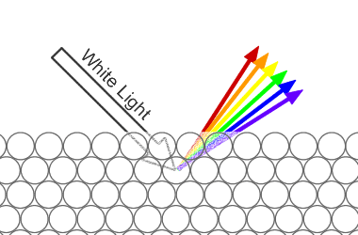

**Play-of-Color in Opal:** White light enters an opal and interacts with the tiny silica spheres that make up its internal structure. The light is diffracted into its component colors and exits the opal in a flash of spectral colors.

## What Causes "Play-of-Color"?

Areas within an opal that produce a play-of-color are made up of millions of microscopic silica spheres arranged in an orderly network. These spheres are only about 1/2 micron in size, and they act as a diffraction grating. As the light passes through, it is diffracted into the colors of the spectrum. The size of the spheres and their geometric packing determine the color and quality of diffracted light.

## Sources of Opal

[**Australia**](https://geology.com/world/australia-satellite-image.shtml) became an important source of precious opal in the late 1800s. Numerous discoveries in the early 1900s gave the country firm leadership of the world's opal production that was not challenged for over a century. Famous mining areas in Australia include: Coober Pedy, Mintabie, Andamooka, Lightning Ridge, Yowah, Koroit, Jundah, Quilpie and others.

Opal production in [**Mexico**](https://geology.com/world/mexico-satellite-image.shtml) also began in the late 1800s. Mexico is best known for its fire opal in bright yellow, orange and red colors.

A series of opal discoveries in the 1990s made [**Ethiopia**](https://geology.com/gemstones/opal/ethiopian-opal.shtml) an important producer of precious and fire opal. Will growing production in Ethiopia challenge Australia for the world's leadership position?

Other countries that produce precious and fancy varieties of common opal include: [**Hungary**](https://geology.com/world/hungary-satellite-image.shtml), [**Indonesia**](https://geology.com/world/indonesia-satellite-image.shtml), [**Brazil**](https://geology.com/world/brazil-satellite-image.shtml), [**Peru**](https://geology.com/world/peru-satellite-image.shtml), [**Honduras**](https://geology.com/world/honduras-satellite-image.shtml), [**Guatemala**](https://geology.com/world/guatemala-satellite-image.shtml), [**Nicaragua**](https://geology.com/world/nicaragua-satellite-image.shtml), [**Slovakia**](https://geology.com/world/slovakia-satellite-image.shtml), and [**Czech Republic**](https://geology.com/world/czech-republic-satellite-image.shtml). Opal has been produced in several locations in the United States, which include [**Nevada**](https://geology.com/gemstones/states/nevada.shtml), [**Oregon**](https://geology.com/gemstones/states/oregon.shtml), [**Idaho**](https://geology.com/gemstones/states/idaho.shtml), [**Louisiana**](https://geology.com/gemstones/states/louisiana.shtml), California, Arizona, and Texas.

## Wonderful Names Used to Describe Opal

There are many types of opal, and a wide variety of names are used to communicate about them. If you have spent a small amount of time looking at opal, you have probably been surprised by this extensive vocabulary of wonderful names. There is actually a logic behind names such as fire opal, black opal, boulder opal, matrix opal, Coober Pedy, Mintabie, Andamooka, precious opal, opal doublet, and opal triplet. The sections of this webpage below will present that logic and help you see the common sense behind the names. And, since pictures are worth a thousand words, we share our favorite opal photos to help you understand. Enjoy!

|  |
| --- |
| Basic Types of Opal: Precious Opal - Common Opal - Fire Opal |
|  |

**[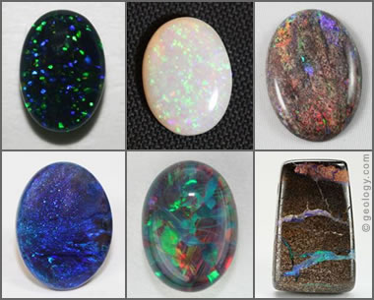](https://geology.com/gemstones/opal/precious-opal.shtml)**

**Precious Opal:** Several examples of precious opal. Clockwise from top left: pinfire opal, white opal, matrix opal, boulder opal, harlequin opal, black opal.

## [Precious Opal](https://geology.com/gemstones/opal/precious-opal.shtml)

"Precious opal" flashes iridescent colors when it is viewed from different angles, when the stone is moved, or when the light source is moved. This phenomenon is known as a "play-of-color." Precious opal can flash a number of colors such as bright yellow, orange, green, blue, red or purple. Play-of-color is what makes opal a popular [**gem**](https://geology.com/gemstones/gems/). The desirability of precious opal is based upon color intensity, diversity, uniformity, pattern and ability to be seen from any angle.

Precious opal is very rare and found in a limited number of locations worldwide. Most precious opal to date has been mined in Australia. Ethiopia and Mexico are secondary sources of precious opal. Precious opal is also mined in Brazil, the United States, Canada, Honduras, Indonesia, Zambia, Guatemala, Poland, Peru, and New Zealand. The accompanying image shows several different types of opal that can be called "precious opal."

**[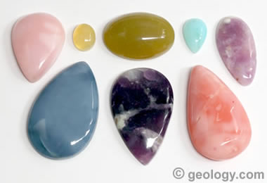](https://geology.com/gemstones/opal/common-opal.shtml)**

**Common Opal:** Several examples of common opal that demonstrate the range of high-end color. Clockwise from top left: Peruvian pink, Oregon yellow, Kenyan green, Peruvian blue, Morado from Mexico, Oregon pink, Morado from Mexico, and Oregon blue.

## [Common Opal](https://geology.com/gemstones/opal/common-opal.shtml)

"Common opal" does not exhibit "play-of-color." It is given the name "common" because it is found in many locations throughout the world. Most specimens of common opal are also "common" in appearance and do not attract any commercial attention.

However, some specimens of common opal are attractive and colorful. They can be cut into gemstones of beauty that accept a high polish. They can be attractive and desirable - but they simply lack a play-of-color that would earn them the name "precious." Common opal is frequently cut as a gemstone and can command reasonable prices.

**[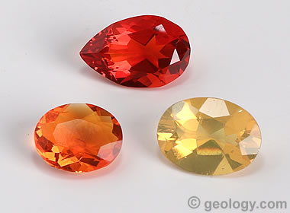](https://geology.com/gemstones/opal/fire-opal.shtml)**

**Faceted Fire Opal:** Three brilliant examples of faceted fire opal, cut from Mexican rough. These gems have uncommon color for any species of stone.

## [Fire Opal](https://geology.com/gemstones/opal/fire-opal.shtml)

"Fire Opal" is a term used for colorful, transparent to translucent opal that has a bright fire-like background color of yellow, orange or red. It may or may not exhibit "play-of-color." The color of fire opal can be as vivid as seen in the three stones shown here.

Some people are confused when they hear the name "fire opal." They immediately expect the "play-of-color" found in precious opal. The word "fire" is simply referring to the red, orange, or yellow background color.

Fire opal might exhibit play-of-color, but such a display is usually weak or absent. Fire opal is simply a specimen of opal with a wonderful fire-like background color. The color is what defines the stone.

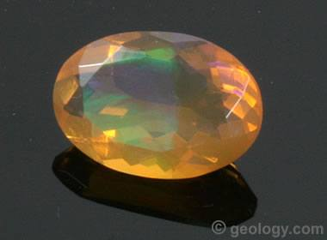

**Precious Fire Opal:** A faceted orange fire opal with a play-of-color that alternates between green and purple depending upon the direction of observation.

## Precious Fire Opal

If you understand the difference between "precious opal" and "fire opal," here is another variation. This opal from Ethiopia has an orange bodycolor, making it a "fire opal," and it also contains an electric green to purple play-of-color, making it a "precious opal." So, we might call this a "precious fire opal." Much of the [**Ethiopian opal**](https://geology.com/gemstones/opal/ethiopian-opal.shtml) currently being produced has yellow, orange or reddish bodycolor, along with play-of-color, that allows it to be called "precious fire opal."

|  |
| --- |
| Opal Names: Based Upon Opal and Host Rock Relationships |
|  |

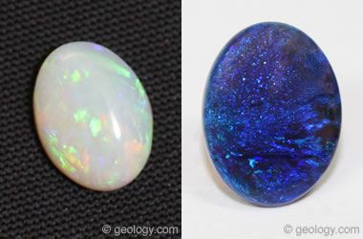

**Solid Opal:** Two examples of solid opal. On the left is white opal from Coober Pedy, Australia. On the right is black opal from Lightning Ridge, Australia.

## Solid Opal --- (Type 1 Opal)

"Solid opal" is a name used for a rough or cut stone that consists entirely of opal material without any host rock or other significant [**inclusions**](https://geology.com/gemstones/inclusions/) contained within the stone.

Solid opal can be a combination of precious opal and common opal. Solid opal is also known as "Type 1 Opal." Solid opal is what most people think of when they think of opal.

**[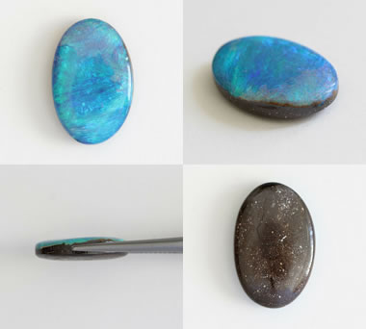](https://geology.com/gemstones/opal/boulder-opal.shtml)**

**Boulder Opal:** The cabochon shown in the four views above was cut from a rock that contained a very thin seam of precious opal. The cutting was skillfully planned to position the thin seam of precious opal as the face of the stone, while preserving a small amount of host rock to serve as a natural backing. The result is a gem that displays full face-up color with a beauty that exceeds or rivals most solid opals. The rough was mined in Winton, Queensland, Australia. It measures 16.89 x 10.98 x 4.19 millimeters. The stone and the photos are by [**Shinko Sydney**](https://www.shinkosydney.com.au/).

## [Boulder Opal](https://geology.com/gemstones/opal/boulder-opal.shtml) --- (Type 2 Opal)

"Boulder opal" is a term used for a rough or cut opal that displays precious opal within its host rock, or precious opal attached to its host rock. Much opal forms within the voids and fractures of its host rock, and specimens of boulder opal can reveal this aspect of opal's origin. Some boulder opal occurs in thin seams and layers that can be cut into a stone that displays only precious opal in the face-up position.

The contrast of color between opal and host rock can be striking. Bright flashes of precious opal are enhanced when seen within dark brown [**sandstone**](https://geology.com/rocks/sandstone.shtml) or with a backing of black [**basalt**](https://geology.com/rocks/basalt.shtml). Red fire opal flashing from pink [**rhyolite**](https://geology.com/rocks/rhyolite.shtml) is also an impressive sight. Many people enjoy the natural appearance of boulder opal and find these gemstones to be beautiful, interesting, and educational.

In Australia, boulder opal is often called "Type 2 Opal". In Mexico, opal cut within its rhyolite host rock is often called "cantera".

**[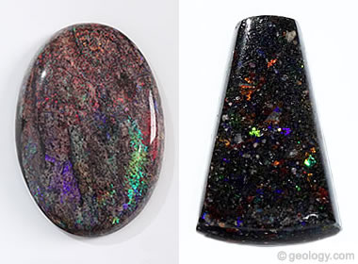](https://geology.com/gemstones/opal/matrix-opal.shtml)**

**Matrix Opal:** The specimen on the left is a cabochon cut from matrix opal mined at Andamooka, Australia. The specimen on the right is a bead cut from matrix opal mined in Honduras.

## [Matrix Opal](https://geology.com/gemstones/opal/matrix-opal.shtml) --- (Type 3 Opal)

"Matrix opal" is a name used for rough or finished gemstones in which precious opal occurs in intimate mixture with the parent rock. This differs from boulder opal, in which the opal is confined mainly to seams and fractures.

Much matrix opal is found in [**sedimentary rocks**](https://geology.com/rocks/sedimentary-rocks.shtml) such as sandstone, [**limestone**](https://geology.com/rocks/limestone.shtml), [**chert**](https://geology.com/rocks/chert.shtml), or ironstone. In these rocks precious opal has precipitated within the interstitial spaces between sedimentary particles. In some cases it replaces sedimentary material. Andamooka, Australia is the world's most famous locality for matrix opal.

Some matrix opal is found in [**igneous rocks**](https://geology.com/rocks/igneous-rocks.shtml) such as basalt, [**andesite**](https://geology.com/rocks/andesite.shtml), or rhyolite. In these rocks the precious opal often occurs as replacements of mineral grains or as infillings of isolated tiny vesicles. Much matrix opal in igneous rocks is found in Honduras, [**Central America**](https://geology.com/world/central-america-satellite-image.shtml).

|  |
| --- |
| Opal Names Determined by Base Color |
|  |

**[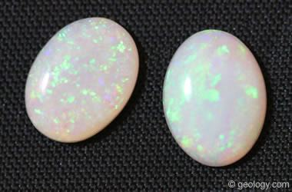](https://geology.com/gemstones/opal/white-opal.shtml)**

**White Opal:** Two cabochons of white opal cut from material mined at the famous Coober Pedy, Australia locality. They are calibrated 8 x 6 millimeter cabs.

## [White Opal or Light Opal](https://geology.com/gemstones/opal/white-opal.shtml)

"Light opal" and "white opal" are names used for precious opal with a white, yellow or cream bodycolor. These are the most common bodycolors for precious opal - especially in the early opal that was mined in Australia.

Until the last few decades, white opal was what most people in the United States thought of when they heard the word "opal" - because other varieties of opal were seldom seen in jewelry stores in the United States.

Coober Pedy, South Australia is the most famous locality for producing white opal.

**[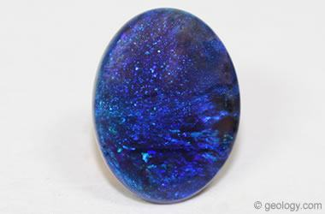](https://geology.com/gemstones/opal/black-opal.shtml)**

**Black Opal:** A cabochon of black opal cut from material mined at Lightning Ridge, Australia. It weighs 2.46 carats and measures 9.5 x 12.5 millimeters.

## [Black Opal or Dark Opal](https://geology.com/gemstones/opal/black-opal.shtml)

"Black opal" is a term used for opal that has a dark bodycolor, often black or dark gray. The term is also used for opal that has a dark blue or dark green bodycolor. The dark bodycolor often makes the play-of-color in black opal more obvious.

The contrast of play-of-color to bodycolor makes black opals very desirable and able to be sold for high prices. This specimen is a solid black opal with a strong blue face-up play-of-color. It was mined at Lightning Ridge, Australia, the "Black Opal Capital of the World." It is 2.46 carats in weight and 9.5 x 12.5 millimeters in size.

**[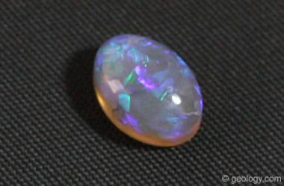](https://geology.com/gemstones/opal/crystal-opal.shtml)**

**Crystal Opal:** A beautiful cabochon of crystal opal with blue and violet play-of-color. It measures 8 x 6 millimeters and was mined at Lightning Ridge, Australia.

## [Crystal Opal](https://geology.com/gemstones/opal/crystal-opal.shtml)

"Crystal opal" is a name used for transparent to semi-translucent opal that flashes play-of-color surprises from within the stone as it interacts with light.

Crystal opal cabochons make a beautiful collector's stones. Crystal opal is a challenge for a designer because they must produce a setting that allows light to enter and exit the stone in a variety of directions to take full advantage of its colorful display - but dangle earrings are a favorite.

Australia was the first abundant source of crystal opal. In recent years, more is being produced in Ethiopia.

**[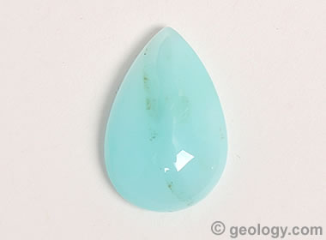](https://geology.com/gemstones/opal/peruvian-opal.shtml)**

**Blue Opal:** A beautiful cabochon of blue opal from Peru. It measures 13 x 8 millimeters and weighs 2.3 carats.

## [Blue Opal](https://geology.com/gemstones/opal/peruvian-opal.shtml)

Many people have never seen blue opal and are surprised to learn that such a material exists. It is often cut into beautiful beads and cabochons.

Blue common opal is a highly regarded variety of common opal best known from sources in Peru, Oregon, and Indonesia.

Owyhee blue opal mined in Oregon ranges in color from a light to a dark pastel blue. Blue opal beads from Peru sometimes contain tiny translucent zones with play-of-color. The blue opal found in Indonesia is usually associated with opalized wood.

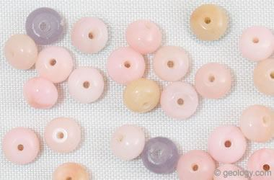

**Pink Opal:** Beads of pink opal made from material mined in Peru.

## Pink Opal

Opal also occurs in shades of pink. These pink opal beads were made from common opal mined in Peru. They are about four millimeters across and range in color from nearly white, through carnation pink, through lilac.

Peru is the best-known source of common opal with a pink color. Small amounts of pink opal are found in Oregon. Some people call the rhyolite-hosted fire opal of Mexico a "pink opal".

**[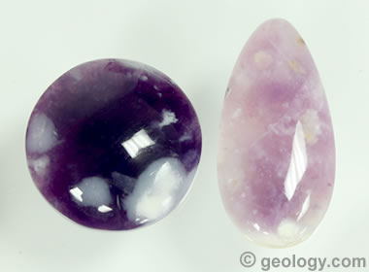](https://geology.com/gemstones/opal/morado-opal.shtml)**

**Morado:** Two cabochons of Morado opal from Mexico. A 19 millimeter round and a 13 x 26 millimeter teardrop.

## [Morado Opal](https://geology.com/gemstones/opal/morado-opal.shtml)

"Morado" is the Spanish word for "purple." Some common opal with a purple bodycolor is produced in Mexico. It is widely known as "Morado Opal" or simply as "Morado". In the world there are very few sources of opal with a rich purple color.

|  |
| --- |
| Names That Describe an Opal's Color Pattern |
|  |

**[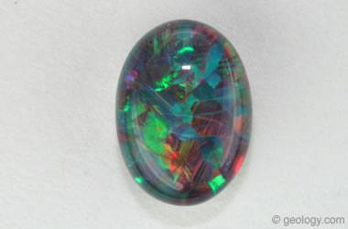](https://geology.com/gemstones/opal/harlequin-opal.shtml)**

**Harlequin Opal:** A beautiful harlequin opal from the Constellation Mine in Spencer Idaho. It is 6 x 4 millimeters.

## [Harlequin Opal](https://geology.com/gemstones/opal/harlequin-opal.shtml)

"Harlequin opal" is a name given to an opal that displays patches of color in the shape of rectangles or diamonds.

The "Harlequin" color pattern is normally exhibited in two dimensions on the face of the stone. However, less often the color patches can be seen within a transparent stone - in a three-dimensional display. This is what you will see in the stone in the accompanying image.

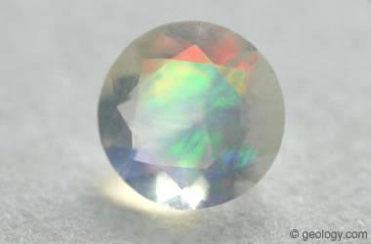

**Contra-Luz Opal** displays its play-of-color when illuminated by a light source on the back side of the stone. An example is holding the opal up to a sunny sky and observing it from an angle that allows sunlight to pass through the stone and into the eye of the observer. Photo by Sandy Craig of [**Orca Gems**](https://www.etsy.com/shop/orcagems).

## Contra-Luz Opal

"Contra-Luz" is an intriguing variety of opal that best displays play-of-color when the light source is behind the stone and the light travels through the stone and into the eye of the observer.

Because the contra-luz effect only occurs when light travels through the stone, a contra-luz opal must be transparent or semi-transparent.

Utilizing contra-luz opal in jewelry requires a setting that allows light to pass through the stone. An example would be a pair of earrings made using beads of highly transparent contra-luz opal that dangle below the ear lobes. Light passing through the beads will produce a display of color when the observer, the light source, and a bead are in alignment.

**[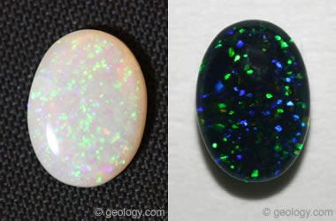](https://geology.com/gemstones/opal/pinfire-opal.shtml)**

## [Pinfire Opal (also Pinpoint Opal)](https://geology.com/gemstones/opal/pinfire-opal.shtml)

"Pinfire opal" is a name used for opal that has pinpoints of color throughout the stone. The opal on the left is a pinfire opal cut from material mined at Coober Pedy, Australia. The stone on the right is a pinfire opal from the Constellation Mine in Spencer, Idaho. It is 6 millimeters by 4 millimeters in size.

**[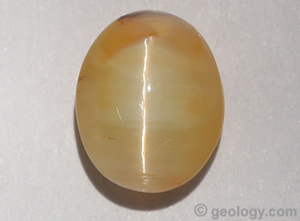](https://geology.com/gemstones/opal/cats-eye-opal.shtml)**

## [Cat's-Eye Opal](https://geology.com/gemstones/opal/cats-eye-opal.shtml)

Rarely, opal will display [**chatoyancy**](https://geology.com/gemstones/chatoyancy/), the optical effect that produces a "cat's-eye" across the surface of a stone. In these opals, a thin line of bright light is reflected from a parallel network of needle-shaped inclusions within the gem.

The line, or the "eye", tracks back and forth across the dome of the stone as the stone is moved, as the light source is moved, or as the head of the observer is moved. Shown here is a cat's-eye opal from [**Madagascar**](https://geology.com/world/madagascar-satellite-image.shtml). Its chatoyancy is produced by hundreds of parallel [**rutile**](https://geology.com/minerals/rutile.shtml) needles that span the width of the stone and reflect a line of light much like the line of light that is reflected from the surface of a spool of silk thread.

|  |
| --- |
| Opal Names Determined by Geography |
|  |

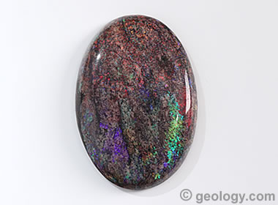

## Andamooka Opal

Andamooka is one of the early mining districts of South Australia. Commercial production began there in the 1920s. The area is famous for its matrix opal - with the play of color distributed through a matrix of [**limestone**](https://geology.com/rocks/limestone.shtml), [**sandstone**](https://geology.com/rocks/sandstone.shtml) or [**quartzite**](https://geology.com/rocks/quartzite.shtml). The stone in the photo is a cabochon cut from Andamooka matrix and weighs about 30 carats.

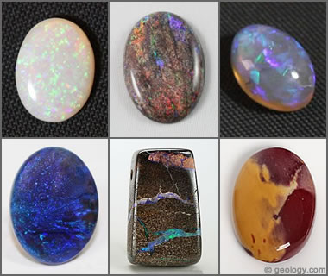

## Australian Opal

Australia has been the world's leading source of opal for over 150 years. It has produced ten times more opal than the rest of the world combined. Numerous world-famous localities in the country produce distinct varieties of opal. [**Precious**](https://geology.com/gemstones/opal/precious-opal.shtml), [**black**](https://geology.com/gemstones/opal/black-opal.shtml), [**matrix**](https://geology.com/gemstones/opal/matrix-opal.shtml), water, [**boulder**](https://geology.com/gemstones/opal/boulder-opal.shtml), jelly, [**common**](https://geology.com/gemstones/opal/common-opal.shtml), and other types of opal are all found in Australia.

Shown in the photo, clockwise from top left: Precious white pinfire opal from Coober Pedy; matrix opal from Andamooka; crystal opal from Lightning Ridge; mookaite common opal from Western Australia; boulder opal from an unknown locality; black opal from Lightning Ridge.

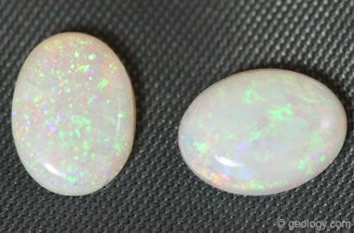

## Coober Pedy Opal

Coober Pedy is a small town in South Australia that was first settled in 1916 when mining for opals began. It was one of the early prolific producing areas and has earned the nickname of "Opal Capital of the World." Coober Pedy is famous for producing white base-color opals, and production has continued uninterrupted since 1916. The stones pictured are white Coober Pedy opals cut to a calibrated size of 8 x 6 millimeters.

**[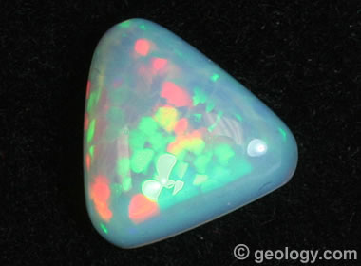](https://geology.com/gemstones/opal/ethiopian-opal.shtml)**

## [Ethiopian Opal](https://geology.com/gemstones/opal/ethiopian-opal.shtml)

Gem-quality opal from Ethiopia began entering the market in significant amounts starting in 1994. Since then, additional opal deposits have been discovered that might be large enough in size to take significant market share away from Australia, which has supplied nearly 100% of the opal market for over 100 years. Precious opal, fire opal, and very attractive common opal are all being produced in Ethiopia. They are becoming more abundant in the gem and jewelry market and more popular with consumers.

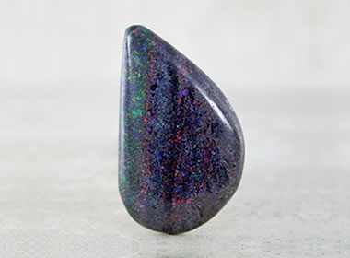

## Honduras Black Opal

Honduras is well known for producing a black, basalt-matrix opal that contains tiny vesicles filled with play-of-color opal. Most people who know opal will understand exactly what you are talking about if you use the term "Honduras Black Opal." The specimen shown is a cabochon cut from Honduras Black Opal. Cabochon and photo by [**Stony Mountain Studio**](https://stonymountainstudio.com/).

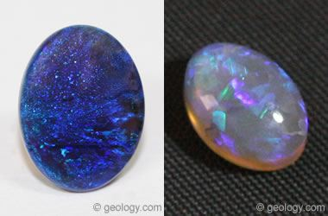

## Lightning Ridge Opal

Lightning Ridge is a town in New South Wales, Australia that has become world-famous for its deposits of black opal. More black opals have been produced at Lightning Ridge than at any other location in the world. The specimen on the left is a solid black opal with a strong blue face-up color mined at Lightning Ridge. It is 2.46 carats in weight and 9.5 x 12.5 millimeters in size. The specimen on the right is a solid crystal opal with blue to lavender play-of-color cut as an 8 x 6 cabochon.

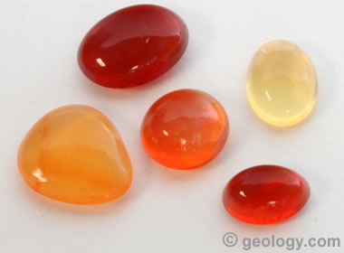

## Mexican Opal

Mexico is famous for being the world's most important source of [**fire opal**](https://geology.com/gemstones/opal/fire-opal.shtml). Mexican fire opal is known for having the most saturated and purest hues. Mexican fire opal is cut into beautiful cabochons, and much is cut into brightly-colored faceted stones. Mexico also produces beautiful [**precious opal**](https://geology.com/gemstones/opal/precious-opal.shtml). A unique cutting style, known as cantera, yields cabochons that display pockets of fire opal in their [**rhyolite**](https://geology.com/rocks/rhyolite.shtml) matrix. The cabochons shown here were cut from fire opal found in Mexico. They all have a bright red, orange or yellow background color.

**[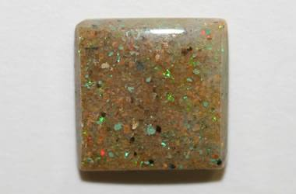](https://geology.com/gemstones/states/louisiana.shtml)**

## [Louisiana Opal](https://geology.com/gemstones/states/louisiana.shtml)

"Louisiana opal" is a quartzite cemented with precious opal that has been mined in Vernon Parish, Louisiana. On close examination you can clearly see quartz grains with the spaces between them filled with a matrix of clear cement that produces a play-of-color in incident light. It is a stable material that can be cut into cabochons, spheres and other objects. Some of the material is brown like the 20mm x 20mm cabochon pictured, but it also occurs in a gray to black color that makes the play-of-color easier to see.

**[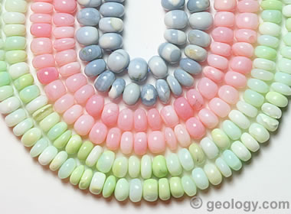](https://geology.com/gemstones/opal/peruvian-opal.shtml)**

## [Peruvian Opal](https://geology.com/gemstones/opal/peruvian-opal.shtml)

Peru produces some of the world's most beautiful opal. It is not play-of-color opal; instead, it is common opal of uncommon color. Opal mines in Peru yield common opal in pastel colors of blue, green, and pink. The accompanying photo shows strands of rondelle-shaped beads in all three colors. Play-of-color is not needed to have beauty in common opal. The beads in the photo are about seven millimeters in diameter. Peruvian opal is also used to make beautiful cabochons and tumbled stones.

|  |
| --- |
| Names Used for Assembled Stones |
|  |

**[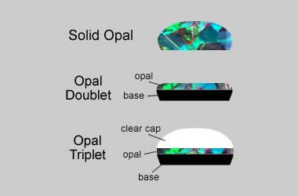](https://geology.com/gemstones/opal/composite-opal.shtml)**

## [Assembled or Composite Stones](https://geology.com/gemstones/opal/composite-opal.shtml)

Most cut opals are **solid stones**. The entire stone is cut from a single piece of rough (see top illustration).

However, some opal rough has very thin but brilliant layers of play-of-color material. Some artisans cut the stone down to the thin color layer and glue it to a base of obsidian, potch, basalt, or plastic - then cut a finished stone. These two-part stones are called "**opal doublets**" (see center illustration).

To protect the fragile opal from abrasion and impact, some artisans glue a transparent cap of quartz, spinel or other transparent material onto the opal. This produces a three-part stone, called an "**opal triplet**" (see in the bottom illustration).

**[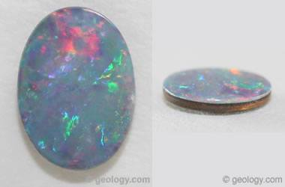](https://geology.com/gemstones/opal/composite-opal.shtml)**

## [Opal Doublet](https://geology.com/gemstones/opal/composite-opal.shtml)

The two pictures shown here are of the same stone. The picture on the left shows the face-up appearance of the stone. The picture on the right is a side view. This stone is an opal doublet that was assembled from a thin layer of precious opal glued to a backing of host rock. In the side view you can clearly see the "glue line" between the two materials. If this stone was mounted in a setting with a cup bezel, it might be impossible to tell if it was a solid opal or a doublet.

**[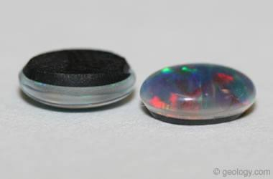](https://geology.com/gemstones/opal/composite-opal.shtml)**

## [Opal Triplet](https://geology.com/gemstones/opal/composite-opal.shtml)

The two stones pictured are opal triplets produced by sandwiching a thin layer of precious opal between a backing of black obsidian and a cover made of clear synthetic spinel. The clear top acts like a magnifying lens and enhances the appearance of the thin precious layer. The black obsidian back provides a contrasting background that makes the play-of-color in the precious layer more obvious. If you look very closely at the inverted stone, you will see a tiny line of color that is the edge of a thin slice of precious opal.

|  |
| --- |
| Names Used for Opal and Opal Look-Alikes |
|  |



## Natural Opal

Because of opal's beauty and desirability, people have been producing materials that look like opal for nearly a century. A person with a little experience can easily recognize most of the "look-alikes." "Natural opal" is the name used for genuine opal that has been mined from the Earth. It is genuine opal made by nature and not by humans. The specimen here is a black opal mined at Lightning Ridge, Australia.

**[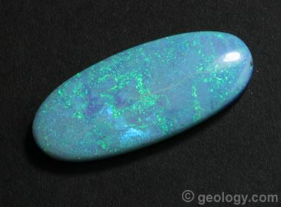](https://geology.com/gemstones/opal/synthetic-opal.shtml)**

**Synthetic Opal:** A beautiful cabochon of synthetic opal with a beautiful blue and green play-of-color. This cabochon measures about 27 x 12 millimeters and was produced by Sterling Opal.

## [Synthetic Opal](https://geology.com/gemstones/opal/synthetic-opal.shtml)

"Synthetic opal", "lab-created opal", "lab-grown opal", and "man-made opal" are some of the names used for opal which has been made by humans. These opals are made from materials that have the same chemical composition as natural opal. They also have the same physical properties and appearance of natural opal. These man-made opals can have spectacular play-of-color and beauty that rivals some of the best natural opals, and they usually sell for a much lower price.

Synthetic opal has been made since the 1970s. An untrained person might not realize that an opal is synthetic, but trained gemologists can usually tell synthetic opal from natural opal by examination with a loupe or microscope. However, some synthetic opals are so convincing that trained gemologists must send suspect specimens to a laboratory for positive identification.

**[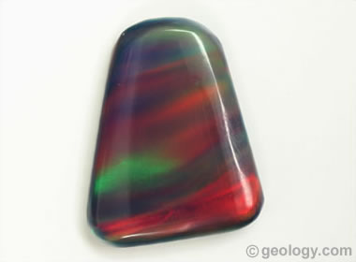](https://geology.com/gemstones/opal/imitation-opal.shtml)**

**Imitation Opal:** A beautiful example of imitation opal with a swirly play-of-color. It is composed mostly of resin. We submitted this stone to the Gemological Institute of America Laboratory to confirm that it was imitation opal and not synthetic opal. It was sold to us as an "Aurora Opal". You can see the report [**here**](https://www.gia.edu/report-check?reportno=5202505180).

## [Imitation Opal](https://geology.com/gemstones/opal/imitation-opal.shtml)

"Imitation opals" are natural or man-made materials that have an appearance that is similar to natural opal. Man-made imitation opals are usually made of glass, resin or plastic. They are not natural opals and must be sold with a disclosure that clearly communicates to the buyer that the item is an "imitation opal" or an "opal-like product" or an "opal imitation". Imitation opals are used as a low-cost substitute for natural opals. They can be as beautiful as natural opals and can sometimes fool an experienced gemologist if they are well made.

Imitation opals have been made since the 1960s. They are becoming more common in the gem and jewelry market, and their appearance is becoming harder to distinguish from natural opal. Many people enjoy their appearance and appreciate their lower cost. They sometimes are sold under trade names that include "Opalite" or "Opal Essence" or "Aurora Opals". Imitation opals are beautiful and legitimate products if they are sold with clear disclosure.

|  |
| --- |
| Other Opals |
|  |

**[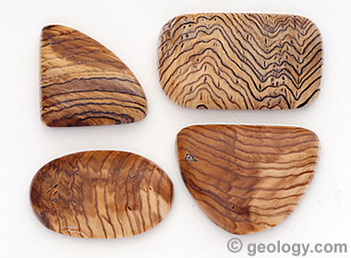](https://geology.com/gemstones/opal/opalized-wood.shtml)**

## [Opalized Wood](https://geology.com/gemstones/opal/opalized-wood.shtml)

Opalized wood is a type of petrified wood that is composed of opal rather than chalcedony or another mineral material. It almost always consists of common opal, without play-of-color, but rare instances of petrified wood composed of precious opal are known. Petrified wood composed of opal is often thought to be composed of chalcedony because many people do not know that petrified wood can be opaline. These two types of silicified wood can be easily separated by testing their hardness, specific gravity, or refractive index.

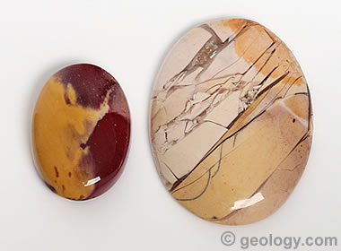

## Mookaite Opal

"Mookaite" is the trade name for an opaque gem material with spectacular color patterns that is mined in Western Australia. Gemological testing identifies most mookaite as a chalcedony. However, some mookaite has the refractive index and specific gravity of opal. The cabochon on the left has the familiar color pattern of mookaite. The cabochon on the right has the less-familiar brecciated appearance. Both can be properly called "common opal". Here's the [**GIA lab report**](https://www.gia.edu/report-check?reportno=2205043949&s=1561308750936) for the stone on the left.

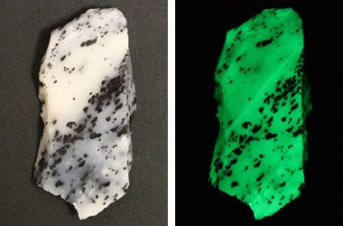

## Fluorescent Opal

Most opal will glow or fluoresce weakly under an ultraviolet lamp. However, some specimens exhibit a spectacular fluorescence. This specimen of mossy common opal rough from Virgin Valley, Nevada fluoresces a brilliant green under UV light. The photo on the left was taken under normal light, and the photo on the right was taken under a short-wave ultraviolet lamp.

**[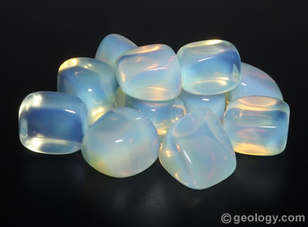](https://geology.com/gemstones/opal/opalite.shtml)**

## [Opalite](https://geology.com/gemstones/opal/opalite.shtml)

The name "opalite" has been used in two ways. Its original use was for common opal without play-of-color. That definition of opalite has been published in geology and gemology glossaries for decades. In the 1980s, the name "opalite" started to be used as a marketing term for a plastic imitation opal with true play-of-color. That use has since spread to a variety of plastic and glass materials that look like opal or have an opalescent appearance.

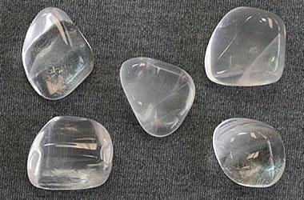

## "Water Opal" or Hyalite

Some opal does not exhibit a "play-of-color," does not have a base color, and does not have a bodycolor like most common opals. But this material is still opal. The tumbled opals pictured are examples of this material. It has been called "water opal" and "hyalite."

<https://www.australianopalcentre.com/opal>

Opal is the most magnificent of precious gemstones. It boasts every colour of the visible spectrum, from deepest and clearest blues and greens to rippling golden orange; through delicate pink and violet to rich turquoise, shocking vermilion, carmine and fuchsia - every colour imaginable.

An opal may contain any or all of these colours, arrayed in wondrous patterns with names like harlequin, pinfire, Chinese writing, flower garden, mackerel sky, flagstone and rolling flash. Like all fine things, gem opal is exceedingly rare.

Much of the world’s precious opal is mined in the harsh outback of Australia, where a unique combination of geological conditions permitted the formation of opal near the margins of an ancient inland sea. Australia is regarded as the world's leading source of opal and of the world's finest opal. In 1994, opal was declared Australia’s National Gemstone.

Opal is found in several other countries including Brazil, Mexico, Ethiopia, the United States, Canada, Peru, Indonesia, Honduras, Slovakia and the Czech Republic. Each location produces a distinctive opal type; in the future, we will add photos and information about these to the Australian Opal Centre website.

### Colour and Formation

**What gives opal its colour?**  
Opal is made of tiny spheres of silica dioxide - spheres so tiny they can only be seen using an electron microscope.

In precious opal – the name given to opal with spectral colours, or 'play of colour' – the tiny spheres of silica dioxide are uniform in size and stacked in regular rows and layers. This configuration creates lattices that diffract white light into different colours of the spectrum. The tiniest spheres produce violet-coloured opal; the largest, red, with sphere size increasing from the violet to the red end of the spectrum.

The great majority of opal does not show play of colour and is called common opal or potch. Common opal is typically grey, black, white or amber-coloured, but is also found in other hues. Common opal does contain tiny balls of silica dioxide, but they are irregular in shape, size and/or arrangement.

**How does opal form?**  
Opal forms after water containing dissolved silica seeps into openings and cavities in rock or clay, then as the water slowly dries out, microscopic spheres of silica dioxide begin to form. The combination of pH and other chemical conditions required for opal formation is extremely specific and occurs only rarely in nature.

### Cost and Rarity

**Why is opal so expensive?**  
Opal is a precious gemstone, like rubies, emeralds or diamonds. Opal is rare, and it is expensive to prospect and mine for. Dozens of miners can work for months, using expensive machinery and spending tens of thousands of dollars on fuel, and between them find only a single fine opal, or perhaps a few. So high-quality opal is costly and in fact, should be valued more highly than it is!

Remember, though – not all opal is expensive: there’s an opal for everyone. If you can afford to own a phone or a car, or even to buy a hamburger, you can afford an opal.

**How rare is opal?**  
Silica is one of the most common minerals on the planet, but precious opal is very rare – far more rare than diamonds. Precious opal is rare because the natural processes that create it rarely occur.

Most (at least 95%) of the opal found by miners is common opal without gem colour. In Australia we call it potch. It can be white, grey, black or amber coloured. Even when a miner finds gem-coloured opal, most of it can’t be cut into gemstones because it’s too thin, or sandy.

### Types of Opals

**What is black opal?**  
Black opal is the most rare and highly valued form of opal, and has what is called a black (or dark) body tone. Black opals come in every colour of the rainbow. Their dark body tone makes the colours on the face of the opal appear rich and intense.  
  
If you ignore the colour in an opal, how dark is it? If it is black or near-black, it is called a black opal. Opal with a dark, but not black, body tone, is referred to as dark opal.

**What is light opal?**  
Light opal is opal with a light body tone. The colours in precious light opal have a beautiful soft, pastel quality. The lightest of light opal is also sometimes called white or milky opal.

**What is crystal opal?**  
Crystal opal is translucent: if you hold it up to the light, some light will pass through. It doesn’t have a crystalline structure like amethyst or diamond – it’s called ‘crystal’ simply because its translucency or transparency resembles that of crystalline materials such rock crystal or glass.

When you look at Australian crystal opal with a light shining through from behind, the body of the opal takes on a warm orange colour.

Although most crystal opal has a light body tone, sometimes it can be as dark as black opal. In that case, it is called Black Crystal.

**What is boulder opal?**  
Boulder opal is opal cut with a natural backing of host rock. The best-known boulder opal is from Western Queensland, where the opal forms in cavities within a brown-coloured, iron-rich rock called ironstone.  
  
If the opal is in a thin layer on dark ironstone, it looks rich in colour and dark in body tone, like black opal. Sometimes opal is distributed in thin, irregular veins throughout the ironstone. This is called boulder matrix.

Boulder opal country also produces thicker ‘pipes’ of crystal opal, formed when the opal infilled cylindrical cavities left by burrowing invertebrate animals, tree roots or fallen branches.

**Why is potch called opal?**  
Potch is opal; it is exactly the same mineral – microscopic spheres of silica dioxide. The only difference is that in potch, the tiny spheres are jumbled, whereas in precious opal they’re all laid out evenly, stacked like oranges in a crate.

## https://geology.com/gemstones/opal/synthetic-opal.shtml

## What Are Synthetic Opals?

Synthetic opals are man-made [**opals**](https://geology.com/gemstones/opal/) that have the same chemical composition, internal structure, physical properties, and appearance as natural opals. They are often called lab-created opals, lab-grown opals, or cultured opals to indicate their man-made origin.

Synthetic opals can exhibit a spectacular play-of-color appearance that often exceeds the beauty of many natural [**precious opals**](https://geology.com/gemstones/opal/precious-opal.shtml). They are produced in a wide range of colors and patterns that many people enjoy.

Many synthetic opals look so much like natural opal that trained gemologists can have difficulty separating them from natural opals. This is why whenever synthetic opals are advertised or presented for sale, sellers are required by law to clearly communicate that they are manufactured by people and they are not natural opals.

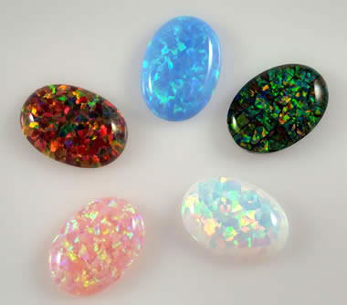

**A Few Dollars Each:** Attractive synthetic opal cabochons like the ones shown in the photo above can be purchased at retail for a few dollars each. That price would be much lower if they were being purchased in large quantities. Manufacturers in countries where labor costs are low have become so efficient that the cost of a cabochon is minimal. Image copyright iStockphoto / jillyafah.

## Synthetic Opal's Price Advantage

The main reason that people produce synthetic opal is a hope of being able to manufacture it at scale and at a price that is lower than natural opal. They have been incredibly successful. Many types of synthetic opal are now cut into beautiful ring-size [**cabochons**](https://geology.com/cabochons/) that sell for just a few dollars each. Even the very best synthetic opal can be cut into cabochons and sold for just a small fraction of the price of natural opal cabochons of similar size and appearance.

Synthetic opal certainly wins some buyers away from natural opal, but it is not likely to displace natural opal from the gem and jewelry market. Why? Most people who love opal are glad to pay a higher price to own a [**gemstone**](https://geology.com/gemstones/) that formed within the Earth - and, in their opinion, no synthetic material will ever compete with that! These people insist on the real thing!

ADVERTISEMENT

## The Many Uses of Synthetic Opal

Synthetic opal is a beautiful material, and its wonderful play-of-color is appreciated by many people. It is therefore no surprise that its use as a decorative material has extended far beyond jewelry. Shapes, small particles, and thin sheets of synthetic opal are being used to adorn musical instruments, jewelry boxes, vases, art objects and many other items.

Kyocera, a leading manufacturer of synthetic opal, has developed a fast-drying gel that contains tiny suspended particles of synthetic opal that can be used as a fingernail polish. [2] The future will certainly see synthetic opal being used in a wide variety of applications.



**Play-of-Color in Opal:** The spectacular play-of-color exhibited in natural opal is caused by light interacting with millions of sub-micron silica spheres neatly stacked within the opal. As light passes through these neatly-stacked spheres, it is diffracted into its component colors, and exits the stone in a flash of spectral colors. These tiny spheres were discovered in 1964, revealing the recipe for making synthetic opal.

ADVERTISEMENT

## How Synthetic Opals Are Made

The cause of opal’s play-of-color was discovered in 1964 using an electron microscope. An array of tiny silica spheres, with a uniform size of less than ½ micron in diameter, in a close packing arrangement, serves as a natural diffraction grating to separate visible light into the colors of the spectrum. [3] [4] This discovery revealed how opal’s fabulous play-of-color is produced and provided the blueprint for making a synthetic precious opal.

The first synthetic opals were made by precipitating tiny silica spheres of uniform size, and allowing them to settle into a close packing arrangement. The spaces between the spheres were then filled with a binding medium that would harden, hold the structure together, and allow the diffraction of light. [5]

Creating synthetic opal was different from the creation process for most other synthetic gem materials. Other gem materials are single crystals, and growing the crystals is the key to producing the gem material. Synthetic opal creation presented multiple challenges: creating millions of spheres of identical size; settling them into perfect arrays (which requires as much as a year or more of time); and, binding the spheres together into a material with a durability that is suitable for a gem. Binding the spheres often requires impregnation of the opal by a polymer resin, an ingredient that is not in natural opal. In addition to improving durability, the polymer resin can improve translucence, luster, and color. Synthetic gem materials are often treated for the same reasons as natural gem materials.

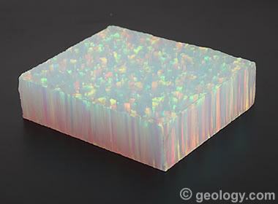

**Columnar Growth Pattern:** The photo above shows a block of rough synthetic opal revealing its columnar growth pattern. The columns are the vertical features visible on the sides of the block. This block is approximately 1 1/2 inch x 1 1/2 inch in size.

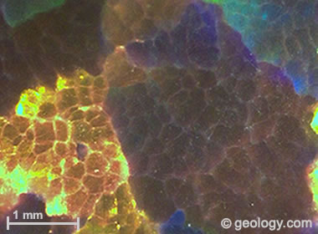

**Chicken Wire or Lizard Skin:** Many types of synthetic opal display a chicken wire or lizard skin pattern when a polished surface is viewed under magnification in reflected light. Each "cell" or "scale" in this pattern represents the outline of a growth column of the synthetic opal.

## Identifying Synthetic Opal

Synthetic opal has been in the marketplace since the 1970s. Many of the early synthetic opals could easily be separated from natural opal with a quick examination unaided by magnification; however, the manufacturers of synthetic opals have been improving the appearance of their products, and today many of them are more difficult to detect. Features that a synthetic opal might exhibit to reveal a laboratory-grown origin include:

|  |
| --- |
| 1) the play-of-color patches might display a columnar growth pattern when viewed perpendicular to the growth direction (see accompanying photo);   2) under magnification, a synthetic opal's play-of-color areas might exhibit a "chicken wire" or "snake skin" pattern (see accompanying photo);   3) resin-impregnated synthetic opal often has a lower specific gravity than natural opal;   4) play-of-color patches are often more uniform in size and distribution across the face of a synthetic opal;   5) synthetic opals are sometimes stained an outrageous color, or the stain produces absorption bands when viewed through a spectroscope. |

https://www.gia.edu/gems-gemology/winter-2017-gemnews-update-dyed-hydrophane-opal

# **Update on Dyed Hydrophane Opal**

Edward Boehm and Nathan Renfro

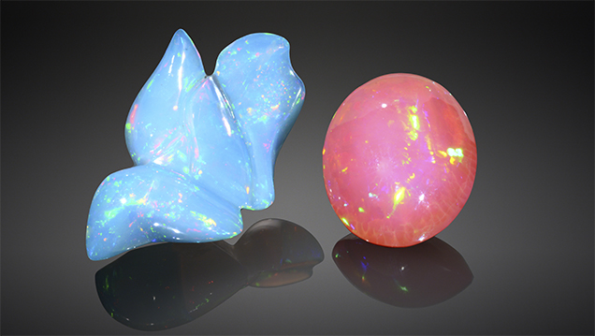Figure 1. These two opals (21.75 and 15.12 ct) were represented as natural-color blue and pink opal from Mexico. Photo by Robison McMurtry.

Dyed purple opals first appeared in the gem trade in 2011 (N. Renfro and S.F. McClure, “[Dyed purple hydrophane opal](https://www.gia.edu/gems-gemology/winter-2011-hydrophane-opal-renfro),” Winter 2011 G&G, pp. 260–270). Recently, the authors became aware of similar material with vibrant blue and pink bodycolors (figure 1). From 2015 to 2017, a jewelry designer reportedly purchased over 500 carats of vivid pink and blue opals from a dealer she met at a small regional gem show in California. The dealer did not disclose that the material was dyed and claimed that these intense colors were from a new opal discovery in Mexico. This kind of misrepresentation could damage consumer confidence in all opals.  
  
In July 2017, author EB received the two opals in figure 1 for examination. After determining that they were likely color treated, he sent both samples to GIA’s Carlsbad lab for further testing. With permission from the owner, each opal was cut in half to obtain a control sample and a test sample. The test samples (one blue and one pink) were soaked in acetone and hydrogen peroxide solutions to determine if their colors were stable. These two opals were carefully examined and, like the dyed purple material from 2011, were consistent with hydrophane opal from Ethiopia that had been dyed. Both stones displayed a “digit pattern” play of color (B. Rondeau et al., “On the origin of digit patterns in gem opal,” Fall 2013 G&G, pp. 138–146). They also showed small spots of saturated color at the surface, consistent with dye (figure 2).

[[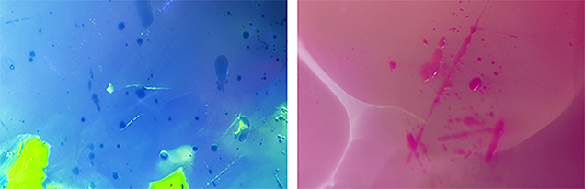](https://www.gia.edu/sites/Satellite?blobcol=urldata&blobkey=id&blobtable=MungoBlobs&blobwhere=1495880744863&ssbinary=true)](https://www.gia.edu/sites/Satellite?blobcol=urldata&blobkey=id&blobtable=MungoBlobs&blobwhere=1495880744863&ssbinary=true)

Figure 2. Both the blue and pink opal showed dye color concentrations around pits and scratches on the surface, consistent with hydrophane opal that has been artificially dyed. Photomicrographs by Nathan Renfro; fields of view 2.34 mm (left) and 1.99 mm (right).

Both stones were soaked in acetone to collect some of the dye material for color spectroscopic analysis. The acetone with residual dye was measured and artificially concentrated by a factor of 20 by multiplying the very low absorption values measured. The measurements produced a spectrum consistent with an organic dye, characterized by broad band absorption features in both the pink and blue samples (figure 3). The absorption measurements were then converted to transmission spectra using GRAMS/AI spectroscopy software by Thermo Fisher Scientific. Color space coordinates were calculated from the transmission spectra and plotted as a color swatch. The hues produced were consistent with the bodycolor of each opal, confirming that the spectra represent the organic dye component (figure 3, inset).

Figure 3. The absorption spectra of the dyes were collected by first soaking the opals in acetone to remove some of the dye material. Color swatches were then calculated from measurements of the dye molecules suspended in acetone to produce the color swatches for reference (inset). These swatches were consistent with the observed bodycolor of each opal.

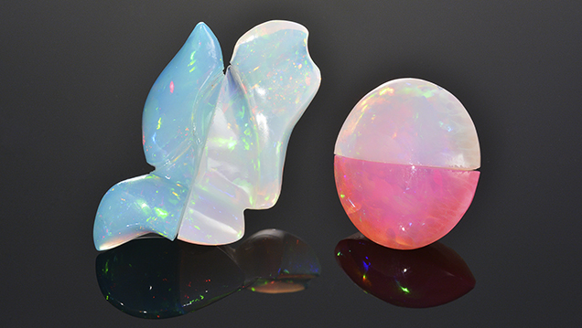

Figure 4. The blue and pink opals were confirmed to be dyed hydrophane opal, likely from Ethiopia. Half of each stone has been bleached using 3% hydrogen peroxide solution. Photo by Robison McMurtry.

The two samples were further tested to see if they could be restored to their original non-dyed state. As reported by Renfro and McClure (2011), soaking dyed purple opal in a solution of hydrogen peroxide removed the purple color. These new pink and blue samples were sliced in half and one piece of each sample was soaked in 3% hydrogen peroxide for up to two weeks. Their color saturation was significantly reduced, with the blue half turning white and the saturated pink half becoming very light pink (figure 4). It is possible that more time in the solution would have further reduced the pink color. Note that even though the samples lost their color, the dye molecules were not removed. But the hydrogen peroxide had oxidatively decomposed the dye into different molecules that did not absorb visible light and therefore could no longer impart color on the opals. Soaking dyed stones in hydrogen peroxide may be an effective way to remove the observed color in dyed opals, returning them to their natural appearance. In our experience, however, there is a risk of cracking when any hydrophane opal is immersed in a liquid.  
  
Acetone allowed the removal of enough dye for spectroscopic analysis, proving that the coloring agent is an organic dye. While soaking the opals in acetone did not seem to greatly affect their color, soaking them in a hydrogen peroxide solution for several weeks removed the artificial color almost entirely. Upon further examination, we determined that they were originally hydrophane opals with a white bodycolor, likely from Ethiopia, that were color treated using an organic dye. These findings reaffirm the importance of treatment disclosure in the trade. A few unscrupulous industry members could compromise the reputation of dealers selling natural opal as well as those properly disclosing treated material to their customers.

<https://www.opal.asn.au/opal-information/opal-industry-nomenclature/>

# Opal Industry Nomenclature

The use of standardised descriptions for Opal is considered key in establishing consumer confidence in the product. For example, when a customer buys a Black Opal at some expense they need to be confident that is indeed what is widely recognised as a “black” and not a lesser stone.

Over the past few years the Gemmological Association of Australia (GAA) has worked at developing a defining nomenclature (that is descriptive naming system) for Opal through a specialised subcommittee chaired by Anthony Smallwood FGAA, GG. After broad industry wide consultations, the following Opal nomenclature system has been developed and is reproduced here with the kind permission of the GAA.

The Opal Association strongly endorses the use of these definitions with the aim of standardising nomenclature across the opal industry worldwide.  
NOTE: Due to a wide variation of colour values portrayed by web browsers and PC monitors, the sample colourings shown in this article can be taken as representative only. For a true representation of the colour definition and tone values of the illustrations reproduced in this paper, please purchase a copy of the original article published in The Australian Gemmologist Volume 19, Number 12, October-December 1997, or purchase the GAA’s Opal Nomenclature Poster

### INTRODUCTION

For many years the terminology and nomenclature used to describe Opal has been widely discussed and debated by gemmologists and those members of the gem and jewellery industry who have an interest in this gemstone. Aspects of this long-running discussion can be seen in the long list of papers published throughout the forty year history of The Australian Gemmologist. But, how to best describe Opal (arguably the most beautiful of gemstones) has been a contentious and difficult issue for a very long time — and may well remain so for some time to come. However, as a consequence of factors such as: growing international and local awareness of Opal as a major Australian resource; the emergence world-wide of a real desire to standardise all terminology related to gemstones; and the ever growing number of synthetics and imitations that are appearing in world markets; it has became necessary to agree on some well based concepts of how a unique gem material, such as opal, should be described.

It was late in 1993 that the Australian Gemstone Industry Council requested the then President of The Gemmological Association of Australia (GAA), Grahame Brown, to initiate investigations into the possibility of establishing a uniformly accepted nomenclature for opal. After a short time, a working sub-committee of the GAA was formed that consisted of representatives of The Gemmological Association of Australia, the Australian Gem Industry Association (AGIA), and the Lightning Ridge Miners Association (LRMA). Now, after three years of discussion, correspondence, and a plethora of drafted documents, and what seemed to be a never ending train of ideas and criticisms, a final draft nomenclature has been agreed-to, ratified, published, and is presented in this paper.

The Australian Gemstone Industry Council (AGIC) has accepted this nomenclature in its final draft, as has the GAA’s 1996 and 1997 Federal Conferences in Tasmania and Perth — albeit with one or two small amendments to the final draft. Now the AGIC hopes to actively progress production of a full colour publication and video on this opal nomenclature for distribution on a world-wide basis over the next twelve months. As Chairman of the GAA’s Opal Nomenclature sub-committee I would like to express my gratitude to Jack Townsend (South Australia), Kathy Endor (Queensland) and Andrew Cody (Victoria) for their untiring efforts and fruitful discussions. Also, this author wishes to express his appreciation for the work and constant liaison of the AGIA sub-committee members Glenn McKean, Drago Panich, Peter Sherman, and Peter Evans, as well as the generous support and hospitality offered by members of the LRMA — in particular Joe Schellnegger, Maxine O’Brien, and Frank Palmer.

I would encourage all members of the GAA to read and to use this nomenclature — in their every day activities, such as buying and selling, and in scientific correspondence and lectures. This nomenclature remains, according to GAA Past President Ronnie Bauer and the AGIA’s Andrew Cody, a ‘living document’. As time passes there will be, no doubt, more discussion and criticism of this nomenclature.This will be most welcome, as are any questions — all of which may be forwarded in writing to the GAA’s Opal Nomenclature Sub-committee either care of the Federal Office of the GAA at P.O. Box A791, Sydney South NSW 1235, or direct to the author at P.O. Box 692, Sutherland NSW 2232.

The nomenclature and classification of Opal, that follows, is reproduced, verbatim, from the Resolutions of the Federal Council of the Gemmological Association of Australia (dated 17th May, 1997).

### OPAL NOMENCLATURE AND CLASSIFICATION

Opal is Australia’s National Gemstone. Australia produces 95 per cent of the world’s supply of precious opal. This nomenclature encompasses all types and varieties of Opal. It provides a standardisation of terminology, but does not establish any methodology of valuation. The Australian Gemstone Industry Council Inc., in collaboration with the Australian Gem Industry Association Ltd, The Gemmological Association of Australia Ltd, the Lightning Ridge Miners Association Ltd, and the Jewellers Association of Australia Ltd, has produced the following nomenclature for the classification of Opal.

### OPAL CLASSIFICATION

Opal is a gemstone consisting of hydrated amorphous silica with the chemical formula SiO2 .nH20. There are two basic forms of Opal described by visual appearance. Precious Opal – is Opal which exhibits the phenomenon known as play-of-colour (Fig. 1A-D), which is produced by the diffraction of white light through a micro-structure of orderly arrayed spheres of silica. Common Opal and Potch – is opal which does not exhibit a play-of-colour (Fig. 2). The distinction between common opal and potch is based on their formation and structure. Potch is structurally similar to precious opal but has a disorderly arrangement of its silica spheres. Common opal shows some degree of micro-crystalinity.

Below are Black, dark and light precious Opals displaying a strong play-of-colour. (Fig. 1A-D)

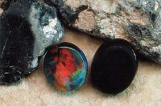

(A) Black opal of N2 body tone and a dominant red-orange play-of-colour.

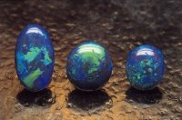

(B) Black opal of N3 body tone and a dominant blue-green play-of-colour.

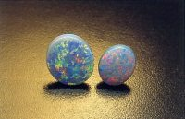

(C) Dark opal of N5 body tone and a green play-of-colour.

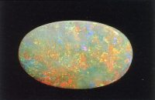

(D) White opal of N1 body tone and a red-blue play-of-colour. (Photographs, R. Weber)

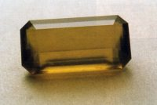

Fig. 2. A faceted common ‘sun’ Opal from Australia. (Photograph, G. Brown).

### TYPES OF NATURAL OPAL

Natural opal is opal which has not been treated or enhanced in any way other than by cutting and polishing. There are three types of natural opal, with varieties described by the two characteristics of body tone and transparency.

* + **Natural Opal Type 1** – is opal presented in one piece in its natural state apart from cutting or polishing, and is of substantially homogenous chemical composition. (See figure 3A).
  + **Natural Opal Type 2** – is opal presented in one piece where the opal is naturally attached to the host rock in which it was formed and the host rock is of a different chemical composition. This opal is commonly known as boulder opal. (See figure 3B).
  + **Natural Opal Type 3** – is opal presented in one piece where the opal is intimately diffused as infillings of pores or holes or between grains of the host rock in which it was formed. This opal is commonly known as matrix opal. (See figure 3C).

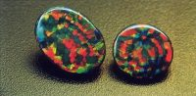

3A. Natural opal type 1 (All opal)

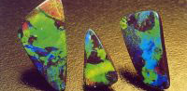

3B. Natural opal type 2 (Boulder opal)

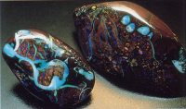

3C. Natural opal type 3 (Matrix opal)

## VARIETIES OF NATURAL OPAL

The variety of natural opal is determined by the two characteristics of body tone and transparency.

### Body Tone

The body tone of an opal is different to the play-of-colour displayed by precious opal. Body tone refers to the relative darkness or lightness of the opal, while ignoring its play-of-colour. This is assessed on a Scale of Body Tone (Fig 4.).  
The boxes (below) comprising this scale, represent approximate values of body tone in equal intervals from black to white. This arrangement is in agreement with all known scales of tone used in colour science, and is well illustrated in the commercially available Rock-color Chart † produced by the Geological Society of America. An AGIA scale of Body Tone is being developed, using computer-generated graphics, and when available, will correlate with the GSA Rock-color Chart.

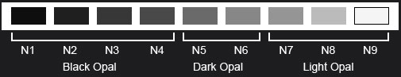  
**Black Opal** – is the family of opal which shows a play-of-colour within or on a black body tone when viewed face-up, and may be designated N1, N2, N3 or N4 on the Scale of Body Tone.

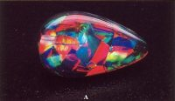

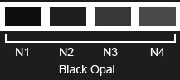

**Dark Opal** – is the family of opal which shows a play-of-colour within or on a dark body tone, when viewed face-up, and may be designated N5 or N6 using the Scale of Body Tone.

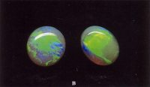

**Light Opal** – is the family of opal which shows a play-of-colour within or on a light body tone, when viewed face-up, and may be designated N7, N8, or N9 on the Scale of Body Tone. The N9 category is referred to as white opal (See figure 1).

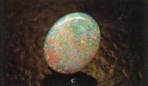

Opal with a distinctly coloured body (such as yellow, orange, red or brown) should be classified as black, dark or light opal, by reference to the Scale of Body Tone, and also have a notation stating its distinctive hue appended to its determined body tone. (See figures 6, 7, 8, 9 &10).

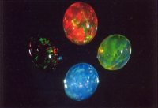

Fig. 6. Mexican opal of black to light body tone and of various hues. (Top) Dark orange crystal opal (Right) Light yellow crystal opal (Bottom) Dark blue crystal opal (Left) Black opal. (Photograph, Weiss Opals, Germany)

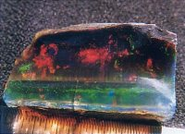

Fig. 7. Black crystal opal from Virgin Valley (USA). (Photograph, P. Brown)

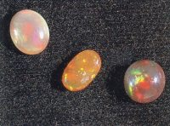

Fig. 8. Indonesian opals of dark to light body tone. (Top left) Light opal (Centre) Dark orange opal (Bottom right) Dark opal. (Photograph, G. Brown)

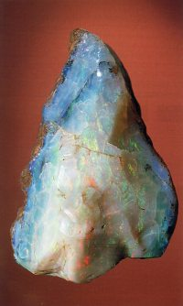

Fig. 9. ‘Hungarian’ opal rough of 594g (13x7x7cm) from the Naturalhistorisches Museum, Wien. This type 1 opal displays body tones ranging from white opal (N9) to dark blue opal (N5).

Fig. 10. Light opal of N7 body tone from Brazil. (Photograph, G. Brown)

## Transparency

Opal shows all forms of diaphaneity that range from transparent to opaque. Natural precious opal which is transparent to semi-transparent is known as crystal opal (Figs. 11A-C). Crystal opal can have either a black, dark or light body tone. In this context, the term ‘crystal’ refers to the appearance of the opal and not its crystalline structure.

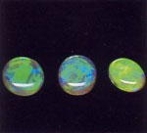

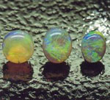

Fig. 11. Crystal opal displaying its identifying diaphaneity. (A) Crystal opals shown face-up against a black background which enhanced the brilliance of these opals’ play-of-colour. (B) The same crystal opals shown face-up against a reflective background that subdues the opal’s play-of-colour. (C) The same crystal opals viewed in transmitted light. Note the play-of-colour of these opals is hidden, and their true transparency is revealed. (Photographs, R. Weber)

## OPAL TREATMENTS

Opal can be subjected to various types of treatment. Present CIBJO guidelines state that any method of treatment other than standard cutting and polishing must be disclosed and the process used specified on all invoices, advertising, and commercial documents. Types of treatments include colour and/or tone enhancement (Fig. 12), heating, painting, dying, resins and waxes, oiling or any application of chemicals. Opal also may be treated to change its natural appearance or durability. (See the discussion on composite opals, below). The body tone of opal is often enhanced (usually appearing darker) in some opal inlay jewellery where a thin piece of solid crystal opal has black paint or black glue applied, or the opal is set above black painted jewellery.

## COMPOSITE NATURAL OPAL

Composite natural opal consists of natural opal laminates, manually cemented or attached to another material. The opal component is natural opal. There are three main forms of composite opal: Doublet Opals – are a composition of two pieces where a slice of natural opal is cemented to a base material (Fig. 13).

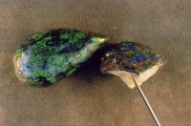

Fig. 12. Treated (carbonised) dark Andamooka matrix opals. (Photograph, R. Weber)

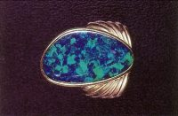

Fig. 13. A ring-mounted black Lightning Ridge-type composite doublet opal. (Photograph, G. Brown)

**TRIPLET OPALS** – are a composition of three pieces where a thin slice of natural opal cemented between a dark base material and a transparent top layer (usually of quartz or glass). Mosaic and Chip Opals – are a composition of small flat or irregularly shaped pieces of natural opal cemented as a mosaic tile on a dark base material (Fig. 14) or encompassed in a resin.

**SYNTHETIC OPAL**– ‘Synthetic Opal’ (Fig. 15A) is material which has essentially the same chemical composition and physical structure as natural opal but has been made by laboratory or industrial process. Synthetic opal composites exist as synthetic opal doublets, triplets or mosaics. These must be disclosed as synthetic opal composites (Fig. 15B).

**IMITATION OPAL** – Imitation Opal (Fig. 16) is material which imitates the play of colour of natural opal, but does not have the same physical and chemical structure or gemmological constants as natural opal.

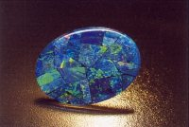

Fig. 14. A mosaic dark opal composite. (Photograph, R. Weber)

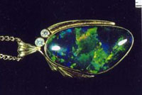

Fig. 15A. A Gilson™ synthetic black opal. (Photograph, G. Brown)

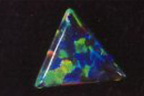

Fig. 16. A ‘thin-film’ imitation dark opal by Pauley. (Photograph, R. Weber)

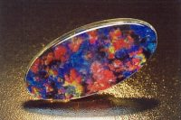

Fig. 15B. A black Gilson™ synthetic opal composite doublet. (Photograph, G. Brown)

## CLASSIFICATION REPORTS

The classification reports for the following types of Opal should include the following:

**Natural Opal**

* Type of opal
* Variety of opal, as black opal, dark opal or light opal with a body tone valueclassification from N1 (black) to N9 (white) based on the Scale of Body Tone
* Transparency as opaque, translucent or transparent. Make note if it is crystal opal
* Weight and dimensions

**Treated Opal**

* Type of opal
* Variety of opal as black, dark or light opal
* Transparency as opaque, translucent or transparent. Make note if it is crystal opal
* Type of treatment and process if known
* Weight and dimensions
* Composite – Type of composite, i.e. doublet, triplet, mosaic or chip opal
* Treatment process, where relevant
* Dimensions

**Synthetic and Imitation**

* Gemmological category (including manufacturer, if known)
* Description (body tone)
* If composite, mention type i.e. doublet, triplet, mosaic or chip.
* Weight and dimensions. Only dimensions if composite.

**Origin**

Any indication of the origin of opal, by the use of geographical location, should not be used unless it is qualified as an indication of the type of locality only as recommended by the International Confederation of Jewellery, Silverware, Diamonds, Pearls and Stones (CIBJO) e.g. Lightning Ridge type black opal.

## HOW TO USE THE NEW OPAL NOMENCLATURE

This nomenclature for Opal has been designed for use throughout the gemstone and jewellery industry, not only in Australia but internationally. While preparing this nomenclature, the sub-committee has been cognisant of conventions of international trade organisations, such as the International Confederation of Jewellery, Silverware, diamonds, pearls and stones (CIBJO), the International Colored Gemstone Association (ICA), as well as the linguistic problems associated with different languages and the differing connotations these languages may place on an internationally acceptable nomenclature.

This new nomenclature has not been designed to force any changes to the various colloquial terms used to describe opal in Australia, or indeed in countries overseas such as Mexico. Colourful language, Australian colloquial terms for opal, and terms that have been a part of the Australian scene for hundreds of years have added significantly to the mystique and folklore of everyday language used on the opal mining fields. Expressive local terms and older historical terms always will exist in the opal miner’s vocabulary. These will remain to have their rightful place in our gemstone history and in the tale-telling for years to come.

The purpose of the nomenclature, therefore, remains to provide a basic description of the gemstone we all prize and know as opal. This nomenclature is for everyone to use and understand. Simple descriptive terms, that can be used by the majority of people, from the customer to the scientist, have been chosen. These provide the gemstone industry as a whole with a logical and unbiased way of grading and evaluating opal. However, simple terms do become difficult when the many different types, formations, pseudomorphic fossil replacements, mineralogical types, and geological occurrences of Australian opal are considered.

Having said that, there are a few items of terminology which it is hoped this nomenclature will remove from common usage. In particular, the terms that have been deliberately removed, due to the linguistic problems they create, are ‘semi-black’, ‘grey’, and ‘solid’.

To begin with the first part of the nomenclature, mention is made of precious opal, potch and common opal. The best way of determining the difference between these is to observe whether or not the opal you are viewing shows the phenomenon which we all know as play-of-colour (compare Figs. 1 & 2). It is possession of this optical phenomenon for which opal is most prized. The differentiation between these basic forms of opal is therefore quite simple. If the opal displays a play-of-colour it is termed precious opal. If a play-of-colour is not displayed, then the opal is either common or potch opal. While it is recognised that the term precious is neither a scientific nor gemmological term, it is retained in this nomenclature for simplicity, and with the intention of further enhancing the value of opal as a gemstone by removing it from any historical association with ‘semi-precious’ gemstones.  
In an attempt at keeping the nomenclature simple to use, the terms common opal and potch opal have not been separated. It must be recognised, however, that there are distinct mineralogical differences between potch and common opal. (Jones & Segnit, 1971).

The term ‘solid’ has been removed from opal terminology, for the simple reason that all types of opal are essentially solid from a scientific point of view. That is, opal does not exist naturally either as a liquid or a gas. ‘Solid’ has been replaced by the gemmological term natural opal. Correlating with this use is the recommendation that when describing doublets and triplets that the term composite be used instead of ‘assembled’ (See Figs. 13, 14 & 15B).This also is the terminology currently recommended by CIBJO.

Essentially there are three types or forms of natural opal, which are termed simply opal, boulder opal and matrix opal (See Figs. 3A, B & C). Perhaps the most contentious issue in the nomenclature concerned introduction of the term body tone, to describe the comparative lightness or darkness of an opal as distinct from its play-of-colour. Technically, it would have been best just to have two types of ‘body tone’ — either ‘black or white’ or just ‘light or dark’. However, the sub-committee rightly decided not to attempt to change too much of the terminology that had been in common use for over a hundred years. So, inclusion of the term black opal was considered to be an imperative. Following much discussion the term body tone was included in the nomenclature to describe the comparative lightness or darkness of opal — irrespective of its play-of-colour. The term tone, which is used by colour science, is in agreement with terminology used internationally to describe the lightness or darkness of particular hues or colours.

The Scale of Body Tone, as illustrated in the nomenclature above (Fig. 4), ranges from N1 to N9. The prefix “N” reflects the neutral tone of this scale.The steps in the scale of body tone, which are arranged to indicate approximately equal decreases of darkness, are difficult to reproduce accurately on the printed page.A rough gauge can be obtained by printing this scale with the assistance of a good computer and a quality laser or ink jet printer.

After examining current industry standards, the N4 category was decided to be the cut-off point for black opal. The AGIA is currently attempting to produce a scale of body tone, using commercially available computer scanning devices and suitable software. However, at the time of publishing this paper, this scale is not yet available. The current reference, used by the Lightning Ridge Miners Association, is the neutral tone scale specified in the American Geological Society’s Rock-colour chart † . This has proved to be a good guide, for in most instances it will be possible to correlate the different ‘tone scales’ into a simple and repeatable system. An acceptable descriptive term was sought also to describe those opals that have distinct body colours or hues, such as those displayed by both Mexican fire opal and honey opal from Lightning Ridge — considerable amounts of which consists of common or potch opal. However, as an acceptable all round term could not be found to describe these opals, the committee decided to describe them by determining their body tone/s, their primary and secondary body colour/s or hues, and their transparency (See Figs. 6, 7, 8, 9 & 10).

To determine the body tone of an opal, then, one examines the piece of opal, face-up, and determines (by visual comparison) its position in the scale of body tone.  
If the tone of the opal appears darker than N4, then the opal may be classified a black opal (Fig. 5A). Consequently, any opal with a body tone darker than N4, irrespective of hue, can correctly be termed black opal. Some boulder opal possesses this body tone, so it is very correctly termed black boulder opal. It is also appreciated that some very dark red Mexican-type opals would have dark enough body tones to be categorised as black opal (See Fig. 6, left).

If the opal is lighter than N4, and its tone corresponds to N5 or N6 on the scale of body tone, then it is classified as dark opal (Fig. 5B). If, in addition, this opal has a decided hue colour, it is additionally classified as, for example, a dark blue opal (See Fig. 6, bottom).

If, on the other hand, the tone of the opal corresponds to N7, or lighter, it is classified as light opal (Fig 5C). If this light opal also has a hue, then it is termed, for example, a light yellow opal.

When to term an opal a crystal opal also provided considerable discussion. The key to classification as crystal opal is really the transparency of the opal (See Fig. 11). Perhaps a better term would have been ‘transparent opal’; but any change in terminology from crystal to ‘transparent’ may take many many years to progress. The obvious problem with the term crystal opal is, of course, the basic fact that that opal has no crystal structure. Again the sub-committee decided that it was unwise to change a term that had been in common use for so many years. The sub-committee further believes that overseas gemmological communities may yet force a change in this usage, if strict terminology is ever to be implemented.

The range of transparency considered acceptable for defining crystal opal (transparent to semi-transparent) was taken straight from Robert Webster’s discussion on transparency in his world-renowned textbook Gems. The committee decided that transparency did not need to be re-defined in the nomenclature; but just stated as a classifying category.

To grade the transparency of an opal with the nomenclature, how transparent the opal is must be determined. If the opal is only translucent, then it is not termed crystal opal. It should be remembered that in some instances the play-of-colour of crystal opal will be so strong or brilliant that assessment of transparency, by the normal ‘read-through’ criterion, may not be possible as the opal can not be ‘read-through’. When this occurs the best test of transparency would be to ‘look-through’ the opal with transmitted light. If transparency exists then this will be readily apparent. If the material remains only translucent, then it is correctly labelled as light opal. It is hoped that future scientific advances may yield a better and more accurate method of assessing transparency.

A note also should be made concerning the removal of the term ‘jelly’ opal. The basic facts are that due to the extreme transparency of this opal it becomes a type of lower quality crystal opal that displays subdued low quality play-of-colour. In spite of any restriction applied by this terminology the term ‘jelly’ opal will probably remain in colloquial use for many years to come.  
The description of composite stones (Figs. 13, 14, 15B) requires only a small change in nomenclature. Instead of these opals being described as ‘opal doublets’ or ‘opal triplets’, the nomenclature emphasises their composite nature by terming these doublet opals and triplet opals. In this terminology, which emphasises the composite nature of these opals, it is the first word of the term that precisely identifies the material.

The rest of the nomenclature discusses opal treatments, synthetics and imitations. These are not associated with the descriptive nomenclature for natural opals, but have been included to complete the nomenclature. These descriptions are in accordance with the latest edition of CIBJO’s Classification of materials and Rules of application for diamonds, gemstones, and pearls.

## ACKNOWLEDGEMENTS

The author wishes to thank Peter Sherman and Frank Palmer for providing specimens for examination. Rudy Weber’s photographic talents are gratefully acknowledged.

**REFERENCES**

* Altman, J.D. (1979) Suggestions for nomenclature of opals. Australian Gemmologist. 13(12), 383-385.
* Clayton, N.A. (1975) Classification and nomenclature of precious opal.Australian Gemmologist. 12(5), 152-154.
* Darragh, P.J., Gaskin, A.J., and Sanders J.V. (1976) Scientific American, 234(4), 84-94.
* Editorial Committee of The Australian Gemmologist (1971)
* Some thoughts on opal. Australian Gemmologist. 11(2), 24-26.
* Geological Society of America (1991) Rock-color chart. GSA: Boulder, Colorado.
* Haugen, S.O. (1987) A system for evaluation of opal. Australian Gemmologist. 16(6), 213-215.
* Herbert, P., Hearnes J., and Males, P.A. (1972) Opal nomenclature discussion.Australian Gemmologist 11(5), 23-24.
* Jones, J.B. and Segnit, E.R (1971) The nature of opal – Opal nomenclature and constituent phases. Geological Society of Australia. 8(1), 57-68.
* Kalokerinos, A. (1971) Black opal nomenclature. Australian Gemmologist 11(4), 16.
* Munsell, A.H. (1961) A colour notation. Munsell Colour Co: Boston, USA.
* New South Wales Opal Research Group (1971) The classification of black opal. Australian Gemmologist. 11(2), 24.
* Sanders, J.V. (1983) A proposal for the classification of opal. Australian Gemmologist. 15(3), 75-78.
* Sherman, G. (1983) Certification of opal. Australian gemmologist. 15(3), 71-74
* Wyszecki, J. and Stiles, R. (1982) Colour Science.Wiley: New York.
* Copies of the Rock-color Chart may be purchased either from The Geological Society of America, P.O. Box 9140. Boulder Colorado 80301 (for US$26.00, plus postage), or from
* Prospectors, P.O. Box 339, Seven Hills NSW 2147 (for $A48.00).

LAST BUT NOT LEAST

<https://www.opal.academy/library-index>

you can read or listen to the information on this website. It has a very good step by step presentation of relevant information that will help you learn the basics before taking the test set out by the Opal Associatio